Ball Mania

Analysis

Introduction and overview
This project revolves around a simple game of obstacles where the players would attempt to move a ball from the starting position to the end, starting from the bottom, and ending at the top, the loss condition being if the ball hits the wall. The idea is that the game would start off really simple and easy at first, but additionally create obstacles that would continue to challenge the player’s mechanical skills as the levels progresses and both the difficulty and the players’ skill go up, the idea of losing upon the ball’s contact with the wall also promotes precision and good predictions on where the ball would end up, creating a level of progression not only in the stages, but in the players too. The project will also offer a time-based scoring system and a timer to incentivise players to replay levels and hone their skills in order to reach a better time and score. My project aims to be a relaxing game that people of all ages can casually enjoy, while retaining a competitive element with it.
My idea for the game mostly stems from the similarities the elements of this game has with golfing games online, being able to move a ball from a starting position to the end proves to be a decently entertaining idea, but I believe it can be enhanced with the addition of more mechanics and the introduction of a timer, turning the game from a game where you minimise the amount of hits needed to minimising the time spent for the ball to reach its destination.
The ideas for the mechanics are mostly inspired by popular platforming tittles (mechanics such as scoring, timer, obstacles), which I believe would make an interesting integration and combination if combined with the basic ideas of a simple golf game.
For the project to function and be satisfactory, I will have to investigate on how to save files and load files within a game context, which I’ve had zero experience with, which the extent of my experience being simple text file reading and writing from lessons. I will also need to create a list of extra mechanics that I feel would be engaging to be included into the project, which might be limited to my personal bias and interpretation, so I will use a simple questionnaire/interview with open questions asking peers on what mechanics they would find enjoyable to be included in the project.

Existing solutions
My game draws inspiration from multiple existing solutions that I would combine and integrate mechanics from. At its core, the game will draw inspiration from the movement mechanics similar to that of mini golf games (e.g. Putt Party as shown below) while taking some inspirations from classic platformers in terms of its mechanics (Super Mario Bros, Geometry Dash etc.)

Putt Party
An existing solution to the golfing game element of the project can be Putt Party, a minigame existing within the social and messaging app discord. It serves as a simple golf game you can enjoy with friends, included with multiple levels and layouts, powerups, and a wide variety of obstacles that aids or prevents the player’s goal. This game is chosen as I would like to integrate some aspects of Putt Party into my game, particularly its movement system, which I believe if put into a context of speed completions, can make for a fresh experience for players.

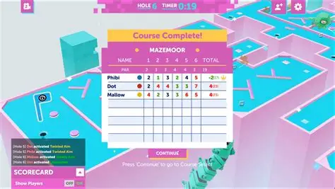
Above is an example of the minigame’s user interface and scoring system based on golf
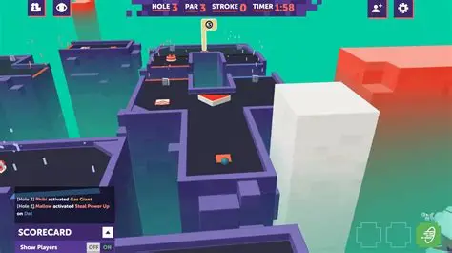
Above is an example of one of the game’s many level layouts along with the display for a powerup seen on the bottom right
Things I would like to include and adapt in my project | Things I would avoid in my project
Simple graphics, the background and foreground of Putt Party is easy and sharp, which does not detour from the main purpose of the game and is easy to take in. This would fit my game’s purpose and a simple background can be implemented to be non-distracting and easy for the eyes | The golf scoring system, as the game featured in the project is not actually golf, and focuses more on the time taken to complete a level as opposed to the amount of strokes needed.
Movement mechanics of the game, the simple idea of dragging with your computer mouse to move the ball is easy and fun to learn and master, and offers good control of the ball in both its direction and speed. This is the main movement system I intend to have my game surrounded by, as it provides good control on the player character precisely. | The system of powerups, this adds randomness in the game that I would rather avoid as it adds unnecessary elements in improving time that is not controllable by the player.
Dynamic obstacles such as the triangular corners/blocks, boost-pads, and spinning bars. Classic obstacles that is included in Putt Party to enhance the base experience of golfing, which I plan to adapt into the project. | Multiplayer, the project is intended to be a singleplayer experience, intended to challenge players mechanically rather than a fun time with friends, so a multiplayer option is unnecessary.
Powerups, inside Putt Party, there are multiple powerups that spices up the gameplay occurring within the golf match with friends, which might be both a boon and a flaw, while this usage of powerups is used inside a multiplayer perspective, using this in singleplayer contexts can also be beneficial to how dynamic the gameplay would be, playing differently according to different powerups, introducing diversity in gameplay. | An in game scoreboard, this is originally used within Putt Party to display the golf scores to the players, but this is unnecessary for my game and we only need a simple box to display simple information such as time spent or collectibles collected.

Super Mario Bros.
An example of the inspiration of mechanics is the Super Mario series, specifically the 2D games. A classic game that many know with revolves around the red plumber getting from the start to the end flag pole of the level, traversing through enemies and obstacles and acquiring powerups along the way. This game was chosen as it is both well known and well designed, the idea of a character gaining extra powers when colliding with an element within a game is a now common game concept that is proven to be fun and interactive with the players, which would make my game more interesting.
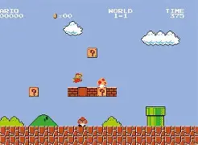
Above is level 1-1 of Super Mario Bros. the classic level of the original game
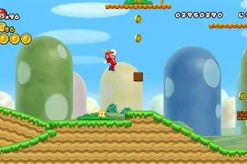
Above is level 1-1 of New Super Mario Bros. a more modern game and take with a larger variety of powerups and mechanics
Things I would like to include and adapt in my project | Things I would avoid in my project
Enemies within the game, this would add challenge to the game that scales difficulty higher than immobile objects. This can also be made very creatively to apply diversity in gameplay such as the introduction of multiple types of enemies (e.g. projectiles, bosses, melee) | Time limit on levels. The game would avoid this as it introduces unnecessary tension that might cause a player to lose motivation or make it harder for the player to learn the mechanics of the game. Furthermore, the levels containing collectibles may take some exploring or detouring to collect or complete, which having a time limit would further add unwanted tension and stress for the player, even if this becomes redundant as the players get better and on repeated attempts, this might still affect players on their first playthrough, causing frustration as they are unable to beat the level due to time constraints.
Multiple stages/scaling difficulty, this introduces a sense of progression into the game that would prove satisfying for players as they see increasingly hard stages and improve their skills to triumph it. | Limited amount of lives/revives. The game incentivises and encourages repetition of levels to improve time and scores, which the limited amount of lives and revives would mean a limited amount of retries, which defeats the point of the game.
Collectibles. Collectibles allow for meaningful repetition of the game for completionists to obtain, once again promoting the element of repetition to improve time and score with each stage. | Destructible environment. In the Super Mario series, some obstacle around the levels can be destroyed for extra reward or just for fun, I believe this to be unnecessary for the game I am creating to include destructible obstacles as it can end up slowing down levels.
Background music. Levels in the Super Mario Bros series has catchy background music accompany it, the music makes lively levels more lively, and tense level more tense; adding a lot more atmosphere into the game, overall enhancing the game’s experience. I would like to replicate this in my game, adding lively music that would accompany more light hearted stages, and suitable music for more tense stages | “Platformer” aspects. The game I am making takes more aspects from game such as Putt Party for movement, so some 2D platformer traits that you’d expect to see within a platformer such as the left to right scrolling levels, edges to jump over etc. would not fit in the game, as it would be done from a bird eye’s view perspective instead.

Geometry Dash
Another example of a game that inspires some ideas for the project is Geometry Dash, a game where you complete auto-scrolling 2D platforming levels, with an incentive of difficult levels being one of the sell points of the game. This game is chosen as it contains elements in which I’d like to take forward into my game, such as the simplistic graphics and intuitive gameplay loop, although some aspects would be avoided such as the auto-scrolling levels.
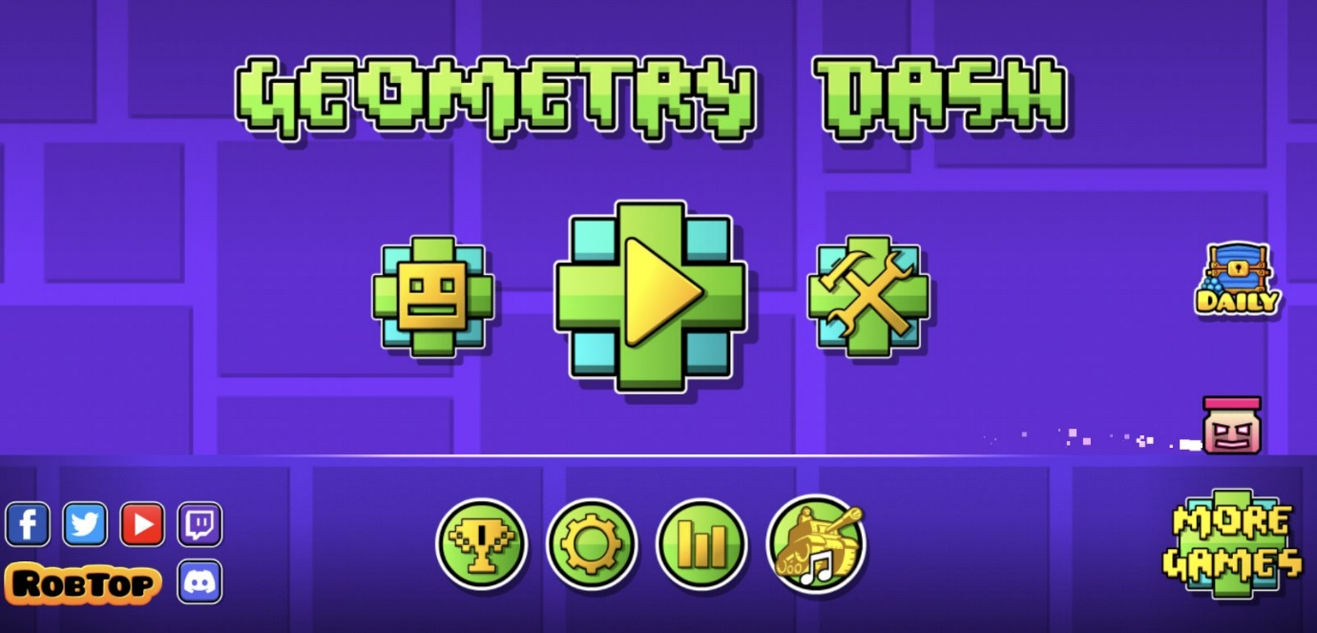
Above is the Geometry Dash’s main menu
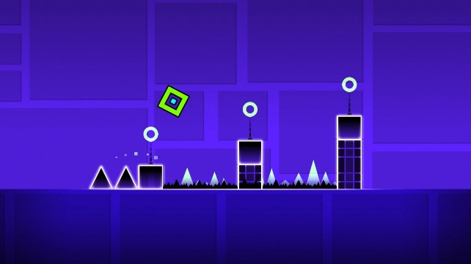
Above is one of the levels of Geometry Dash
Things I would like to include and adapt in my project | Things I would avoid in my project
Simple and effective game menu. The menu of Geometry Dash is simple and clean, delivering all information necessary to its players without any complicated visuals, which I would like to implement to my game for the same reason to avoid unneeded overcomplication of the menu so that players can play the game intuitively | Variety of player modes. Geometry Dash offers multiple modes that the player character can take instead of the original cube such as a spaceship that diversifies the gameplay I believe this to be unnecessary for my project as the game revolves around getting really good at one specific mobility system, not multiple.
Dangerous obstacles. This include things such as spikes and is used to increase the tension and challenge offered by the levels, challenge the player more. | Rhythmic aspects. Geometry Dash is considered a game where you would click according to rhythms provided from the music, I believe this to be unnecessary for my project as it does not fit well with the themes nor does it provide a lot in value for diversifying gameplay
Colour scheme. The levels of Geometry Dash contain contrasting and very distinguishable background and foreground, highlighting clearly where the obstacle is, and where the background decoration is. Adaptation of this in my project would help players access the game better as it would be clear on whether an object is a part of the background or stage since it’d be clearly outlined. | Practice mode. In Geometry Dash, you are able to temporarily save your position in the middle of a level for repetition in practice, which is unneeded with my project as the whole game revolves around repeating the same stage for practice.
Collectibles. In Geometry Dash, levels can contain coins that the players can go out of their way into a side/more difficult path to collect, this is a very effective way to make completionist players replay levels, which I would like to implement in my game to encourage more replaying of levels. | Ability to create levels: Geometry Dash offers players the ability to create custom levels for others to play, which is one of its biggest sell points. I consider this to be unneeded for my game as it would add unneeded complexity to my game, which its progression is intended to be fairly linear.
Easy to understand gameplay loop. Geometry dash contains one actual input button – the mouse click. This makes the game extremely easy to learn and understand even for younger people, but can be extremely hard to master as level difficulty increases. I want to replicate this kind of accessibility and intuitiveness in my game, making sure people can understand its core mechanics without being confused, but the mechanics would be difficult to master as the levels gets harder in the game. | Auto scrolling levels. In Geometry Dash, levels are auto scrolled until the player character has not failed and reaches the end of the level. For a reason similar to time limits, I would not add this feature to my game as it creates unnecessary complication and stress within a stage, and becomes largely redundant after some repetitions in levels either way, and might even become limiting as the players develop better skills to complete levels faster, but is blocked by the auto scroll.

Stakeholders
Stakeholders for any sort of project/program is always one of the most important aspects of making a computer program. A project’s stakeholders mean who is going to be the ones making and influencing decisions within the creation of the project/program.
The stakeholder (or target audience) of my game is going to be around the range of 15- to 20-year-old students/adults, specifically keen video game players who is willing to repeat certain levels for a faster completion. The reason the age demographic is due to the nature of repetition promoted by the game, as it contains an innate competitive element in it that is suitable for people who wish to challenge themselves mechanically, which makes it a good fit for the younger audience of teenagers and young adults who are willing to challenge themselves and curious on their limits. The game does not ask for heavy thinking, as opposed to a puzzle game, it is instead of a test of mechanical precision, seeing how fast someone can complete a level, and getting progressively better at the game, this creates a sense of progressive accomplishment even before the stages of repetition where the audience would feel their skill progress even just by going through increasingly complex levels.
The nature of repeating levels for a faster time might prove to be frustrating for younger children, and might prove to be too time consuming for older adults, hence the age range. The game specifically targets more experienced video game players as it hooks a common desire for improvement that a lot of the audience have, making them want to get a faster completion more often compared to someone who is more foreign to video games and may not get the point of repeating the same level for faster completion.
The target audience would use the game to challenge themselves and for entertainment, usually after school/work. This is because the game offers in senses of accomplishment (e.g. beating a personal best on a level) that would offer entertainment and relaxation for a person that just came back from a tiring day of school/work, getting a bit of satisfaction on triumphing the level that they had previously struggled in.
I will conduct a survey within the target age demographic (mostly in the age range 15-18 as older adults tends to be more bust with work and school) in order to grasp a good idea of what feature people would enjoy, and what feature they would not enjoy.

Survey
This is a short questionnaire/survey with a total of 14 closed questions and 1 open question distributed amongst my college peers (aged 16-17), which lies within my target audience age range and respondents are people who frequently play and enjoy video games, getting their input in both quantitative and qualitative form is immensely important as it gives me an insight into what they want and don’t want within the game, ensuring a satisfactory and entertaining product is made by the end of the development process.

Here I will be going through each question is the questionnaire, as well as explaining why it is put into the questionnaire, what the results were, and what the results mean for my game.

My survey collected a total of 19 responses. The first 10 question on the survey was about gameplay elements within the game.

Question 1
“Are you likely to repeat the same level of a video game you like for a shorter completion time?”
This is asked as repetition is one of the core components of the game, I’d question the target audience on whether they’d want to replay the game to improve their skill. This is crucial as this gave me an insight on how likely the players are to actually enjoy the core of the game – repetition making perfection.
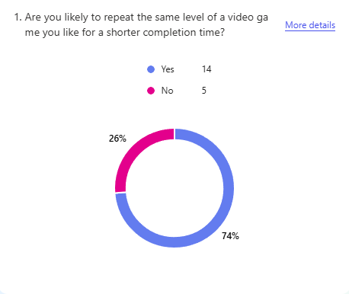
Above is the graph for question 1. As seen above, most of my audience (74%) would be likely to repeat levels of a game for faster completion time. This is advantageous as it can be seen as a proof of concept, showing that a game revolving around repetition of levels for a faster completion is an idea that my target audience would enjoy.
To act upon this, I will focus elements on my game on rewarding players for completing levels faster, such as trophies for completion time. However, I will also ensure that my game is still playable for the 26% who would rather play through the game once, making sure that levels in the game would not be locked away from players due to completion time.

Question 2
“Would you think a game is more entertaining if enemies are involved in a stage?”
This asks the audience on if they would like enemies to appear inside stages. This is asked as it would get an insight into whether the audience shows favourability towards mechanics that would endanger and challenge the player, giving me a useful look into if they would like opponents to go up against
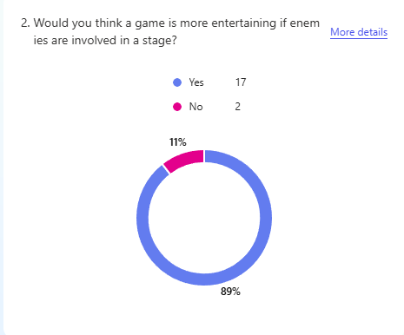
As shown above, a vast majority of my target audience (89%) would like to see enemies involved within the game. This means that most of my audience would enjoy some sort of adversary that would act opposing to our player character.
To act on this, I will put the addition of enemy characters in a higher priority or completion as my survey tells me that my target audience would enjoy that. I would also consider adding an alternative mode/easy mod for the audience that put “No” as their answer that removes some enemies in the game, though that is of lower priority.

Question 3
“When playing a video game, how often do you go out of your way to collect collectibles?”
This asks the audience if they would collect extra collectibles if given the opportunity. This gives me an insight into if my audience would want extra mechanics that might further add replay value into the game. This would also show how committed players would be if I were to add collectibles into the game and how likely they are to repeat the levels to get said collectibles.

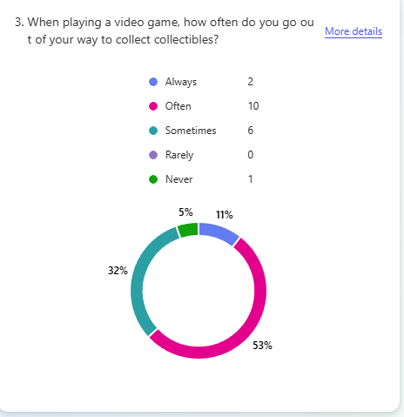
(For this question, I am going to judge any answer that is above ‘Sometimes’ to be positive for collectibles, and anything below it to be negative for collectibles)
Above shows that most of my audience (12/19) felt positively about collectibles in games, and only 1 of the responses showed negative opinions on collectibles. This tells me that the addition of collectibles in my game would be very welcomed, and that this would incentivise the audience to play my game more.
To act on this, I will be including collectibles such as coins into my game, and will create a tracker that rewards players for collecting said collectibles. These collectibles are going to be completely optional to the game’s level progression, so if one of my audience do not wish to collect the collectibles, they do not have to.

Question 4
“Do you prefer a game that is focused on precise controls have a time limit in levels or not?”
This is more of a double check with the audience, I personally wouldn’t want a time limit as it offers unnecessary stress in completing levels, but I decided to consult the audience and double check if they would like a time limit on the levels. Having a time limit might be beneficial as it would provide an extra challenge for the players to overcome, so some players might prefer it.
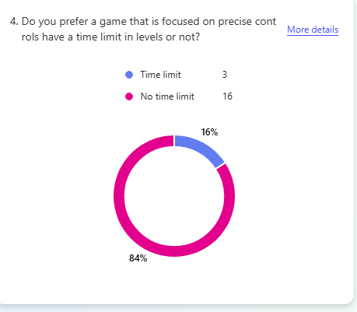
As seen in the above graph, most of my audience (84%) showed favourability into having no time limit within levels, this confirms my suspicion that players often prefer levels without time limit to allow more freedom as they can explore and experiment with mechanics without worry about the timer. However, a minority (16%) of my audience did say they’d prefer a time limit within the game so I can consider their opinions aswell.
To act on this, I can create separate modes for the game: one with a timer, and one without a timer, which is completely optional and is fine to do either without affecting anything. However, the timed mode would be lower in priority and should be disabled on default as the majority prefers not having a time limit.

Question 5
“Would you want a video game you play to be challenging?”
This queries the audience on if they like difficulty within their video game of choice. This is important as it would guide me to make and tailor the difficulty such that it would be enjoyable and entertaining to my audience, instead of too easy to be boring, or too difficult to be frustrating.
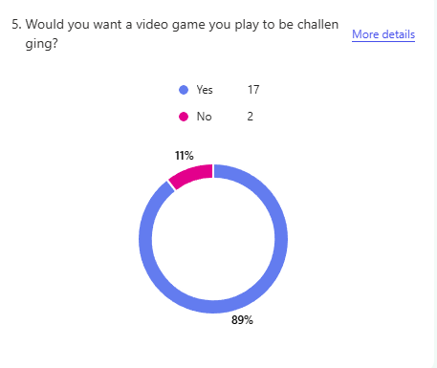
As seen with the graph, most of my audience (89%) like challenging games, there are some that dislikes difficulty, which would be taken into account.
To act on this, I would make my game have multiple difficulty modes same as above, where an easy mode is possible that reduces the difficulty of the game for those that wants a more relaxed experience, though the mode would be in lower priority. Otherwise, the normal mode of the game would be decently challenging and I will attempt to make levels that actually challenge players mechanically.

Question 6
“What is your opinion on mechanics such as boost pads, spikes and teleporters that can either aid or harm the player?”
This asks the audience’s opinion on obstacle-like mechanics. This gives me an insight into if the audience would like to face a variety of other obstacle aside from potential enemies or walls, letting me know if I should add dynamic mechanics that might make the game more enjoyable.
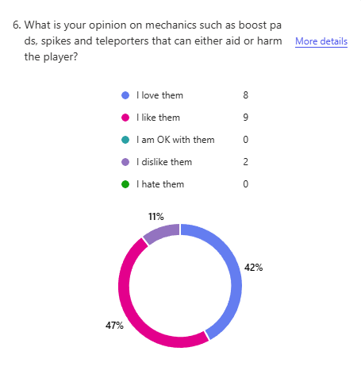
As shown above, a majority (89%) of my audience show positive opinions on obstacle mechanics within the game, meaning that my players would enjoy mechanics that acts as obstacle that can aid and harm you.
To act on this, one of the priorities when developing the game will be adding obstacles as one of the core elements in a level, making sure that a variety of them are added such as boost pads and spikes.

Question 7
“On a scale of 1-10, do you like games centred around completing a level as fast as you can?”
This asks the audience on their opinions on games catered around speed completions. This lets me know if my audience would like a game that revolved around completing objectives as fast as possible, this is one of the main elements I’d like to implement in the game and emphasise, so I must make sure that it is to the taste of my audience.
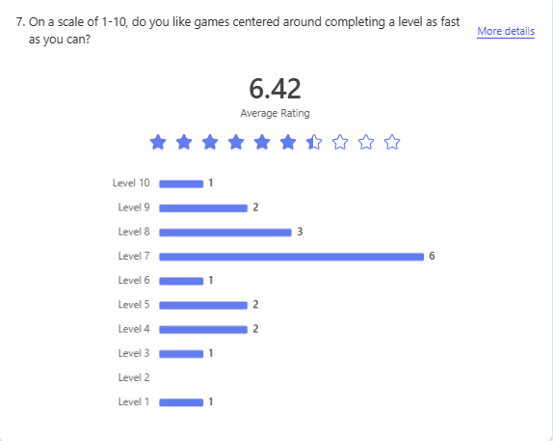
As shown above, my audience show a largely positive, yet a bit mixed reaction to games centred around completing levels quickly. Most of my audience opted to pick the 7/10 option, which I can interpret it as “slightly above average with it, yet I do not like it that much” and both 10/10 and 1/10 have a representation within my responses.
To act on this, I will design my game with a mind on how some of my audience may not like the idea of completing levels as quickly as possible, making sure to balance out the enjoyment for all of my audience.

Question 8
“Do you like games where mechanics are introduced progressively throughout multiple levels, or one big tutorial that explains everything you need to know”
This asks whether the users would like a big tutorial to extra mechanics or have them gradually explained as the game progresses. A third middle option was also introduced that we take a mid way – where we explain some basic mechanics at the start, and extra more complex mechanics are explained later on when needed. This is needed as I would need to know the audience’s preference on how the mechanics is introduced, as to avoid it being overwhelming or confusing to the audience.
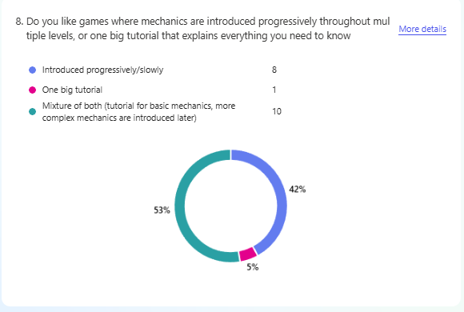
As seen above, most of my audience (53%), would like a compromise between big tutorials and slow introduction of mechanics, and some (42%) opted for a system where mechanics are introduced progressively and only one respondent wanted a big tutorial at the beginning. This shows that most of my audience prefers the mechanics of their game to be introduced as they play the game, while getting a small brief of the basic ones at the start.
To act on this, one small tutorial on basic mechanics in my game would take place in the first level, acting as a sandbox for my audience to get a hold of the movement systems, and when new mechanics are introduced, I would tell them to the audience with a separate tutorial when relevant. The tutorial at the start would be as minimal as possible to avoid confusion with my audience, and the tutorials midway should be clear and intuitive as to not overwhelm the players with a new mechanic that is confusing. This should also be in mind when designing mechanics – how easy would it be to explain this mechanic to my audience without confusing them?

Question 9
“Would you want a restart button within a pause menu?”
This asks the user if they’d want a restart button that would reset the player to their beginning position in the level. This is asked so that I can make sure the players would like a quick way to reset progress and reset their position if wanted, making sure that the player would actually want and use the feature if it was to be added to the game.
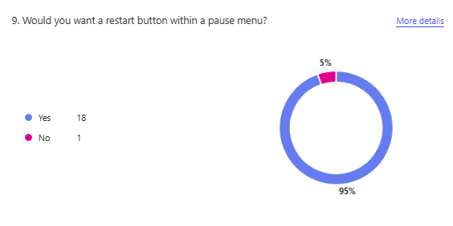
As seen in the graph, most of my audience (95%) would like a restart button within a pause menu, this means that my audience would like an easy and accessible way to restart a level and reposition themselves
To act on this, I will include a pause menu that would include a button to reset the main character back to its starting position as a result of this.

Question 10
“Would you like to have the ability to fight back the enemy (limited usage)”
This question asks if the audience would like a way to fight against enemies, this is important as it would make me aware if enemies were involved in the game, whether it be necessary or not to include mechanics to attack or fight back against enemies.
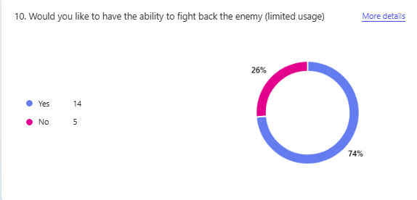
As shown above, most of my audience (74%) would like a mechanic that allows the audience to fight back against enemies (if they were added). Notably, there’s an increase of 3 respondents who want enemies, yet do not want the ability to fight back against them; in total, 26% of them did not want the ability to fight back against enemies.
To act on this, one of my mechanics in the game could be a powerup that gives our player character an option to fight back against enemies, but I should also make levels possible without these upgrades for those who didn’t want to fight enemies.

The next 2 questions are queries about visual elements in the game.

Question 11
“When you play a game, would you want the background of a 2D game to be a simple sloid background, or there to be some minor decorations in it.”
This inquires on the audience’s preference on visual background when playing games. This is important as foreground and backgrounds are often crucial to capture the audience’s attention, so knowing whether the audience want something more simplistic or something more detailed would be needed.
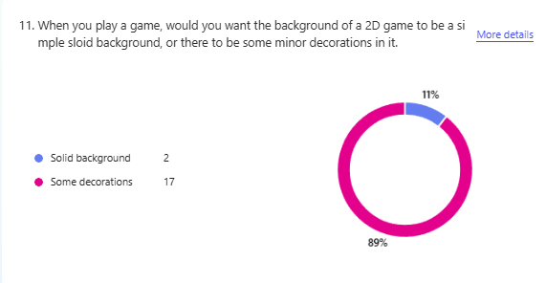
As shown above, most of my audience (89%) would like some decorations to spice up the background of the game.
To act on this, I will implement a background element in my game that is not just a solid background, but considering performance, I can also add an optional setting to change the background to a blank background.

Question 12
“On a scale of 1-10, how much do you like games where the visuals of a game revolves around simple shapes”
This is similar to question 11, but it is instead more focused on the general aesthetic on the game instead of purely the background. This is important as I would need to take into account whether the audience would like a more complex look to the game or not as a more complex look requires extra development time as opposed to simple shapes.
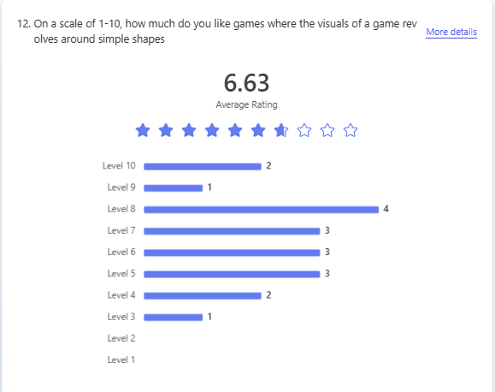
As shown above, my audience showed a mixed yet above average (6.63/10) reaction to simple shapes as my game’s primary visual style. Notably, none of my players reacted below a 3 to the question, and 2 put 10 reacting to the question, whereas only 3/19 showed a reaction rating lower than 5, showing most are at least OK with a game of said style.
To act on this, my game would use simple shape elements as its primary user interface design and level design, avoiding complicated visuals that might not fit the background.

The next two questions are miscellaneous questions on minor stuff that I might want to add.

Question 13
“Would you like a game to have some sort of narrative/story line in the background (not actually explicitly expositioned)”
This queries the audience on whether they would like some sort of storyline within the background of the game. This is needed as many games are further enhanced with their enjoyable story, even if it doesn’t affect gameplay much, so I added the question in the survey to consult my audience on whether or not they would want one and if having a storyline within a game would enhance their experience playing the game. Furthermore, a storyline would require extra development time, so I should double check that it is actually wanted before adding it.
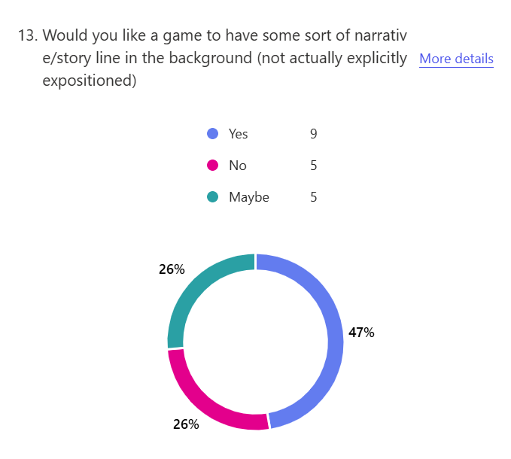

Above shows that my audience remains mixed on whether or not they’d like a storyline of sorts in the game, although the option ‘Yes’ got the most votes, more people chose the other two options (9 vs 10). This indicates that my audience do not particularly mind if there is a story line or not within the project.
To act on this, I will largely regard the want for a story line to be relatively low in terms of priority, and I would only consider this after other elements of the game have been finished.

Question 14
“Would you want the video games you play to contain background music?”
The reasoning for this is similar to the prior question, having some background music while someone plays a video game can further enhance the experience and mood the game is trying to convey to the audience. This also requires extra development time, so getting some confirmation that it is wanted would be needed.
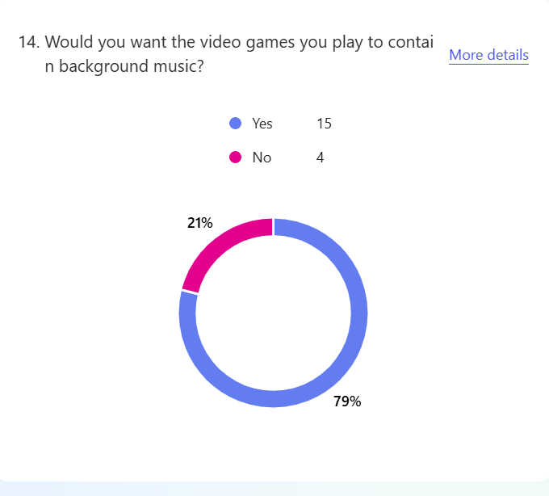
As we can see above, a majority of my audience (79%) do want some sort of background music within my game, this means that I can act on this accordingly and add music within the background depending on the context of the game.
Acting on this, I will consider adding music into my game such that it offers my audience a more entertaining experience when playing the game.

Lastly, the final question acts as an open question asking my audience for any suggestions within my game.

Question 15
“Any ideas for mechanics?”
This is a simple and optional open question for any extra mechanics not mentioned that my audience might want within the game. This is extremely important as only suggesting ideas for myself and from my own experience and scope is extremely limiting and biased, so having third opinions from my own target audience would be extremely important since it is a direct reflection of what the audience wants in the game.
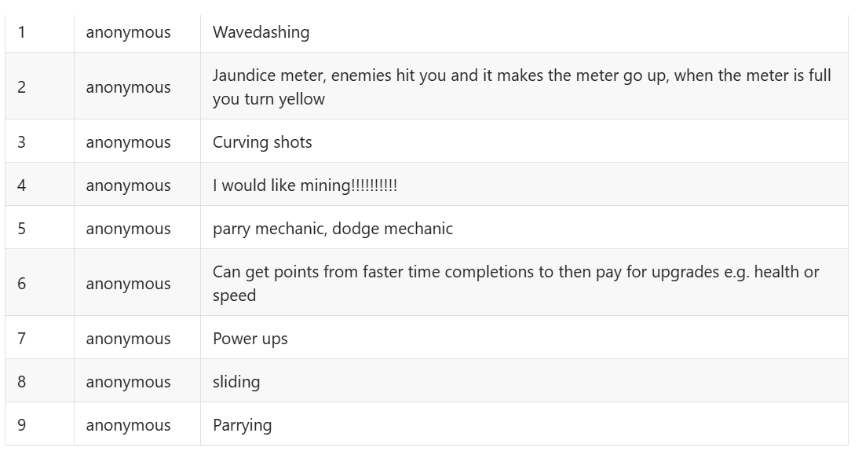
Above is a list of all suggestions submitted by the respondents. Notable suggestions include a parry mechanic, dodge mechanic, upgrades/powerups, additional movement mechanics(e.g. sliding), and a meter of sorts. This is a direct suggestion from my audience, meaning that it is something that my audience would want, so it should be dealt with seriously.
To act on this, I will consider each idea of the suggestions and decide whether it is fitting or not to be included as a mechanic in my game.

User requirements
This is a list of vague features that I have compiled based on both my own opinions/research and that of the results from the survey I’ve conducted.

User requirement | Importance | Reasoning
- Basic movement mechanics | Essential | It is essential within a game that the user is able to move and control the game character, this would include the movement system mentioned where the user would drag their mouse and the player character would move according to the direction and distance the user dragged the cursor  Subsections will include:  - Moving character/control  - Collision
- Main game menu | Essential | It is also essential that a game would provide users a graphical interface that would allow users to start playing the game, configure settings, or leave the game.  Subsections will include:  - Start button  - Settings button/menu (if applicable)  - Stage selection  - Title  - Quit button
- Multiple levels | Essential | It is essential that my game contains multiple stages as it would offer a sense of progression in the game. Furthermore, the game would also be too simple if there was only one level, and it would be difficult to implement multiple mechanics that way.  The game would ideally include around 10 levels, each being unique in some way such as new mechanics.
- Save and load | Essential | The game revolves around the satisfying feeling of getting a new personal best when completing a level, so the ability for these achievements to be saved and reloaded each time the game is launched is necessary. This would hopefully include the
- Win/lose condition | Essential | For a game to be complete, you have to be able to win. So the ability to complete a stage within a game must be included, the same would go for losing.
- Timer | Essential | As the game revolves around you getting a better time for your completions, making such a game without a timer that tracks your completion time is pointless, hence a timer is needed, furthermore, this gives the players a reason to replay levels to get a fast completion time as opposed to just completing it.
- Level design/gameplay elements | Desired | This is more of a broad category of anything gameplay related that enhances the gameplay experience beyond the barebones, as shown by the survey – the audience would highly anticipate and want these features, so they would be very desired.  Subsections will include:  - Powerups (inc. combat & dodging)  - Obstacles (clearly coloured so that it is distinguishable)  - Enemies
- Pause menu + restart | Desired | I would like to give players the ability to pause the game in case they would like to take a break or was called away for something urgent mid game. This would also include the restart feature highly requested by my users, so should be treated higher in priority.
- Rewards + collectibles | Desired | This shares a similar reasonings to no. 8 as it would further enhance the gameplay for the user and incentivise them to replay levels to collect collectibles. Rewards refer to things such as trophies or secrets given to users after they achieve certain things in the game, giving the users a sense of achievement, so this would preferably be added.
- Tutorials | Desired | As shown in the survey sections, I will implement both a beginner’s tutorial and tutorials throughout the stages, this will avoid users from being confused on how to control the game, and would overall allow more players to enjoy the game to the fullest, so it is highly desired.
- Adjustable settings | If possible | Being able to adjust settings such as the volume would help the user play more comfortably and an overall more enjoyable experience, so it is desirable
- Stage decorations | If possible | This refers to background elements and foreground elements in terms of visuals for the stage, it should be simple and clean. Having a decorated background and foreground for the stages is desirable as many users wanted it.
- Background music & sound effects | If possible | Having auditory responses when playing games can largely enhance the gameplay experience for the users, music is also a requested feature according to the survey
- Difficulty modes | Low possibility | The option for difficulty modes were only proposed after seeing the minority response to the survey on not wanting difficult stages and enemies, so it would be lower in the priority list though I’d like the game to be more accessible for all of my audience
- Time limit | Low possibility | Also only considered after seeing the minority in the survey who would like a time limit within the game, the reasoning is similar to no. 14 in that it’d be an optional thing that makes my game enjoyable by more of my target audience, as it is less requested according to the survey, it is placed here in low priority.
- Boss stages | Low possibility | This would’ve been put in dynamic gameplay/elements but is separated as I believe this mechanic can be put in lower priority due to the game being largely functional even without its addition, but having a boss stage would be a good way to enhance the user experience when play the game, so I would still like it to be added
Explanation for importance
Essential: WILL be included in the first iteration of a game, usually is a required mechanic for the base skeleton of the game
Desired: Second priority after essential, usually includes additional mechanics that users asked for that would spice up the experience of my game
If possible: Third priority after desired, usually extra mechanics that was wanted and desired by the audience, but is not required/does not drastically alter gameplay that it would be prioritised
Low possibility: Lowest priority, only done after every other feature in the higher priorities are finished, usually optional modes for a minority of the audience who preferred other ways to play the game.

Success criteria
This follows the user requirement to be an extension of it, partially to further organise and order the importance of subsections within the user requirements, but also to make some of the user requirements more measurable to show what I need to do in order for my project to be considered a success as more of a number than a concept.
No. | Name | Order of importance  (Within its category)  1 is highest priority, = sign means the same | Reasoning
1a | Moving characters/control  - Able to get from point A to B  - Mouse is used to control the player via dragging  - Different direction and intensity of the movement is dependant on the mouse’s distance and direction form the player | = | Both of these are equally important as both are essential for basic functionality of the game
1b | Collision  - Hitting a wall/entity is something that is detected and causes its proper effects | =
2a | Start button  - A button that would launch the player into the game, this should lead into the stage selection screen (2c) | 1 | You will need this to launch the game
2b | Settings menu/button  - A button that would direct the player into the settings menu to configure volume | 3 | Only required when settings is created as a function
2c | Stage selection  - A button that allows players to see and select a stage to play with (including a display for time completion and trophies/collectibles collected), it would follow after the start button  - If time limited mode and difficulty mode was made, the option for this would be displayed here before entering the stage. | 2 | This follows after the start button to be essential as the player has to select a stage somehow
2d | Title  - A title of the game at the main screen | 5 | Mostly cosmetic and does not affect gameplay
2e | Quit button  - A button that allows the user to quit the program | 4 | Not a requirement for functionality, but can be preferred by some players.
3 | Multiple levels  - Ideally include around 10 levels with variety of layout and obstacles | N/A | Mentioned above in user requirements
4 | Save and load  - Ability to save the progress of a game which is reloaded upon the game opening again. It should save: level completion, completion time, trophies, collectibles progress | N/A | Mentioned above in user requirements
5 | Win/lose condition  - The ability to lose a stage and clear a stage  Lose: Contact with projectile/wall (unless specified)  Win: Reach the endpoint of a level | N/A | Mentioned above in user requirements
6 | Timer  - A timer that tracks your level completion time and displays it to the player | N/A | Mentioned above in user requirements
7a | Powerups  - Powerups that are able to add additional mechanics for the user to control for a short period of time.  This would include:  - A dash that would allow the player to gain a great burst of velocity on the next movement via the spacebar  - A shield that gains the player an one-time shield against losing  Only one ability should be active at once.  - Secret powerup that would cause the players to be 3% faster and turn yellow | 3 | Can be optional in gameplay, so I would like to design the levels first without powerups in mind, but add them in afterwards as an optional thing users can get mid stage
7b | Obstacles  - A variety of obstacle that might offer more diversity in level mechanics  This includes:  - Boostpads  - Collision allowed walls  - Corner pieces that would send you perpendicular to the direction you sent the player towards  - Moving environment (e.g. spikes that poke out) | 1 | Having a variety of obstacle can be considered higher in priority than the others as I can base off the obstacle already placed and slowly include enemies and powerups – so it is a good starting point
7c | Enemies  - Opposing entities to the player character, potentially with different types. Should include:  - Melee enemy that chase the player down  - Projectile based enemy | 2 | Reason stated at 7b
8a | Ability to pause  - When a certain key is pressed, the stage progression and timer would pause, and the user is able to take a break, quit the level, or restart the level via the menu displayed | 1 | The restart button and function resides within the pause menu, so the pause menu has to be made first.
8b | Ability to restart  - Resides within the pause menu, would reset a stage’s state to its starting position via a button on the pause menu | 2 | Mentioned in 8a
9a | Collectibles  - Provides the player with a variety of collectible items such as coins which would be recorded in the game, if enough is collected within a stage, a reward/response is expected  Includes:  - 3 coins within each level | 1 | Part of the rewards comes from collecting all the collectibles, so the collectibles should be prioritised first
9b | Rewards  - Given to players in the form of things such as a trophy as a reward for completing objectives such as stages in a certain time, or collecting all of the collectibles.  Includes  - 1st trophy for completing the stages in a set time.  - 2nd trophy for collecting all of the collectibles  - 3rd trophy just for completing the level  - If all trophies are collected, a secret message is displayed along with a secret powerup option | 2 | Mentioned in 9b.
10a | Tutorial (beginning)  - Introduces basic movement mechanic, located at the first level:  Players are told that they can drag their mouse and the player character would move according to it. | = | Equally prioritised as they would be done in the order of stages.
10b | Tutorial (mid playthrough)  - Can be in the form of a small text box/message that would introduce them to what a brand new mechanic such as powerup/obstacle would do to the player character | =
11 | Adjustable settings  - Allows the players to adjust settings such as the volume/keys. | N/A | Mentioned above in user requirements
12 | Background/foreground decorations  - This should be sharp and simple, the foreground should be plain and be distinguishable from the background, whereas the background would be set in some sort of theme according to the level to convey progression | N/A | Mentioned above in user requirements
13a | Music  - Background music that would depend on what and where the user is doing | 1 | Neither of these are particularly needed within the gameplay elements, but would be a cosmetic feature that enhances gameplay, the music would be simpler to add, so can be prioritised to get it over with first, as the sound effect would include many different conditionals
13b | Sound effects  - Auditory feedback for the users after a certain action (e.g. getting hit, winning, selecting a stage etc.) | 2 | Mentioned in 13a
14 | Difficulty modes  - Two modes for players to select:  Normal: usual game, intended mode  Easy: no enemies, only obstacles | N/A | Mentioned above in user requirements
15 | Time limit  - Optional mode in settings for a time limit | N/A | Mentioned above in user requirements
16 | Boss stage  - A final boss stage at the last level that offers players a unique challenge | N/A | Mentioned above in user requirements

Limitations
This includes anything that I have not included in the first iteration of my game due to various reasonings.
Limitations | Reasoning
3D elements | Firstly, a game as simple as mine does not need to be 3D in terms of visual, I personally am fond of the 2D look of games. Furthermore, I have never worked with a 3D game engine or anything 3D related in programming before, so doing so would introduce an unnecessary learning curve for me that could be avoided via doing it in 2D.
Parrying mechanic | Although this is requested by the audience, I’ve decided to not include a parrying mechanic as I cannot think of a good way such as mechanic would meaningfully fit in the game, and I feel like would deviate a bit from how I envisioned the game to be. Furthermore, the implementation of a parrying mechanic is something I have not attempted before. Therefore, while I personally do enjoy parrying mechanics in many games, I believe one is largely unfit and redundant in my game.
Multiplayer | My game is intended to be a solo speed completion experience, the addition of another player makes it much harder to track completion time and would be once again – largely redundant as there would be no realistic reason to add this that would benefit the game that much, meaning it’d add unnecessary development that is meaningless. Therefore, a local/online multiplayer would be avoided when making this.
Multiple bosses | Only one boss will be included in my game as having multiple means that I would have to figure out ways to make these bosses unique and distinct from each other, which would add to my already large workload. Furthermore, multiple bosses would mean the need for more stages to pad in between them and also meaning more work that would mean less time to refine the game. Therefore, multiple bosses won’t be included.
Ability to create your own levels | I had gone through this in the existing solutions section, but I’d like to restate it here. Although the ability to create your own level is an ability that is fun and offers a lot of creativity within a game such as Geometry Dash, I believe this is unneeded within my game as it is more meant to be a game revolving around completing inbuilt levels as fast as possible, having a level creation mode would be too much of a deviation from the reason the game is made and introduced into the market, so would be meaningless. Furthermore, this introduces a huge issue with trying to save these created levels and attempting to add a way to share these same levels, which may both include security problems and be a gigantic problem to solve attempting to save user created levels that is just not worth it in the development time I’ve been given, especially when there is already so many user requirements and success criteria. Therefore, I will not be making a level creation tool/option within my game.
Character customisation | Customising your player character is prevalent in a lot of video games, and can add a lot of familiarity within a game playing as your own creation, but I have deemed it unneeded for this to exist in my game as it would be a redundant feature that a lot of users would skip and would be difficult adding considering the need to create a new character sprite according to user inputs. Therefore, a character customisation will not be added into my game.

Hardware and Software Requirements
I have chosen Java as the primary programming language for my game which I will use the newest version of Greenfoot (3.9.0 updated 29th October, 2024) as the GUI for the game.

Hardware
- As of Greenfoot version 3.6.0 and onwards, it requires a 64-bit CPU to run, so my audience’s devices will need to have a 64-bit CPU to play my game
- My game would require a mouse for movement and interface navigation, and a keyboard for pausing menus and powerups
- A computer/laptop is the intended hardware for my game as it is developed around the usage of a keyboard and mouse.
- The game is unlikely to need powerful processing or lots of memory and storage to run, so most low to mid-range devices (given it fits the other criteria) would be able to run and download my game, this is because Greenfoot is a relatively lightweight GUI to run.
  - This low performance requirement will mean that even some of my younger audience with less advanced/powerful computers will be able to run my game
- For the best experience, a speaker/headphones is recommended as there would be music and sound effects that would enhance the user experience/gameplay.

Software
- As the game is coded on Greenfoot, the computer system running it will also require Greenfoot to be installed to work
- As of Greenfoot version 3.6.0 and onwards, it requires a 64-bit operating system, so my audience will need a 64-bit operating system to play my game
- For most operating systems, no additional installations are needed, but for Debian users, they may need to install Oracle JDK or OpenJDK in order to access Greenfoot. And some operating systems may need to install a Java JDK (8 or above). Though both Windows and Mac OS does not have to worry about this unless the operating system is less than 64-bits.
- Greenfoot does support mobile and tablets (provided it runs the required Java platform and meets other requirements, see Greenfoot FAQ – “Will Greenfoot run on my (xyz)”)
  - However, my game is designed around the use of a keyboard and mouse, so the use of other devices may cause unintended scenarios I will not account for.
  - Within the same section, it is also notable that “Android-based phones and tables including Chromebooks do not run the Java platform” and “Greenfoot cannot normally be installed in these devices), adding another requirement for my audience.
- The latest version of Greenfoot was released late 2024 and supports almost all modern devices such as Windows 7 or above and all modern macs, so most computers will be able to run my game.
  - Most modern computers will be able to run my game, especially commercially available ones. This means that my game will be accessible to a wider scope of my target audience as it has low requirements.
- Greenfoot has a simple installation process (see Greenfoot – Downloads and Greenfoot - Installation), so my target audience, who should have basic computer literacy skills, should be able to navigate and install Greenfoot and run the game as required.

Condensed Requirements
Software
Installing Greenfoot will be required for my game.
Greenfoot – Downloads
Operating System
- Windows 7+
- Mac OS X 10.8.3 +
- Any modern Mac is fine
- Android based devices like the Chromebook can’t run the Java platform, so can’t be used (see Greenfoot FAQ – “Will Greenfoot run on my (xyz)”)
For some other operating system (such as Debian and Ubuntu, see Greenfoot - Installation)
- Some sort of Java JDK (such as Oracle JDK, which is recommended by Greenfoot developers).

Hardware
- 64-bit CPU
- Keyboard
- Mouse
- Speakers/headphones (recommended)

Computational Methods
Under this section, I will explain why a computer is used for my idea, and how I will have implemented these different elements of computational methods into my game.

Decomposition
For the game, many components of my game will be split up into different sections, similar to how I’ve done it within user requirements and success criteria. Furthermore, I will be using Java as the programming language for the game, which uses object orientated programming, this innately uses decomposition in the form of classes and objects. For example, I will separate the elements of obstacles and enemies with different classes, and then I can further separate different obstacles such as a boost pad and corner wall as their own child class of obstacles. Furthermore, the use of OOP allows me to reuse classes and objects in different levels as long as they behave the same, saving me time. The use of Greenfoot as a GUI will also allow me an easy platform to work on without having to test basic functionalities of the game using in built methods and modules within the GUI.

Abstraction
Abstraction is an important concept for a program when it’s being presented, my game will achieve this via removing any unnecessary objects that is not present in the screen of the player, this should improve my game’s performance so that my users can have a better experience. Furthermore, while backgrounds, foregrounds and user interface in some video game titles tend to be more complicated and decorated, I will take a more simplistic approach to this to both decrease development time and improve performance, I will only show users the buttons and interface they needed to see. I will also be removing any unnecessary elements from the background and foreground for the same reason.

Pipelining
My game would make use of pipelining at the end of each level. At the end of a level, data about the level completion such as collectibles collected, time took to complete level will be collected. This information will then be fed to the code and determine how many trophies are awarded to the user. Finally, the code will save this information and display it to the player in a display, as well as saving this information for future display. Another example would be the movement of the player character: first, the code will grab the location of the computer cursor. Secondly, it will calculate the distance the cursor is and the player character (which calculates the power the ball will move with) and it will calculate the direction the mouse is in relation to the player character. Finally, it will launch the ball at certain speed and direction according to the mouse input received. These are suitable to be done with a computer as the collection of data such as the level completion data may be faulty if done manually by a person keeping track of time and collectibles physically, there may also be faults made when deciding whether or not a trophy should rewarded to the player as each stage has a specific time needed for the trophy, meaning that mistakes can be made with humans where they would accidently take the wrong number and misjudge.

Concurrency
Concurrency is necessary when multitasking is involved within a program, my game being the same. For example, the timer that counts the time elapsed during a level will run concurrently any other element within a level such as player movement, enemy movement etc. Doing so allows me to track and use different elements within a level a lot more freely with a computer multitasking as opposed to trying to control multiple elements on a physical board game whilst keeping track of a timer.

Calculation
There will be different calculations done with my game, for example, there are going to be velocity calculations for certain things such as player movement, enemy movement, enemy projectiles, moving obstacles which would be done using code within the game dependant on what the context is. The game should be able to compute and dish out the results of these calculations in quick succession so that the game does not appear to be sluggish and unenjoyable. Furthermore, the game revolves around precise moving for time improvements, so the accuracy of these calculations are needed in order for the best user experience. Using a computer here will be necessary as computers can calculate and run multiple calculations at the same time very quickly, making a computer a suitable media for this instance.

Development Plan

GUI design

Main menu
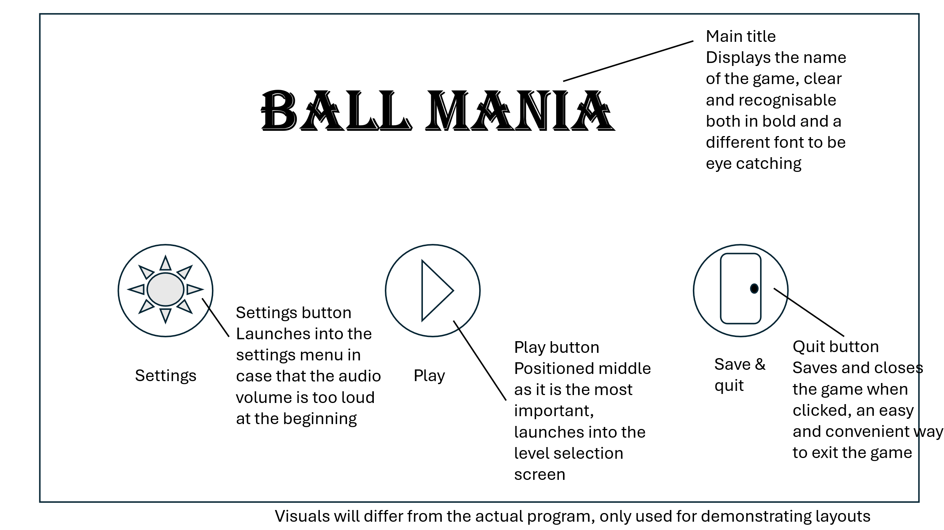

Settings menu
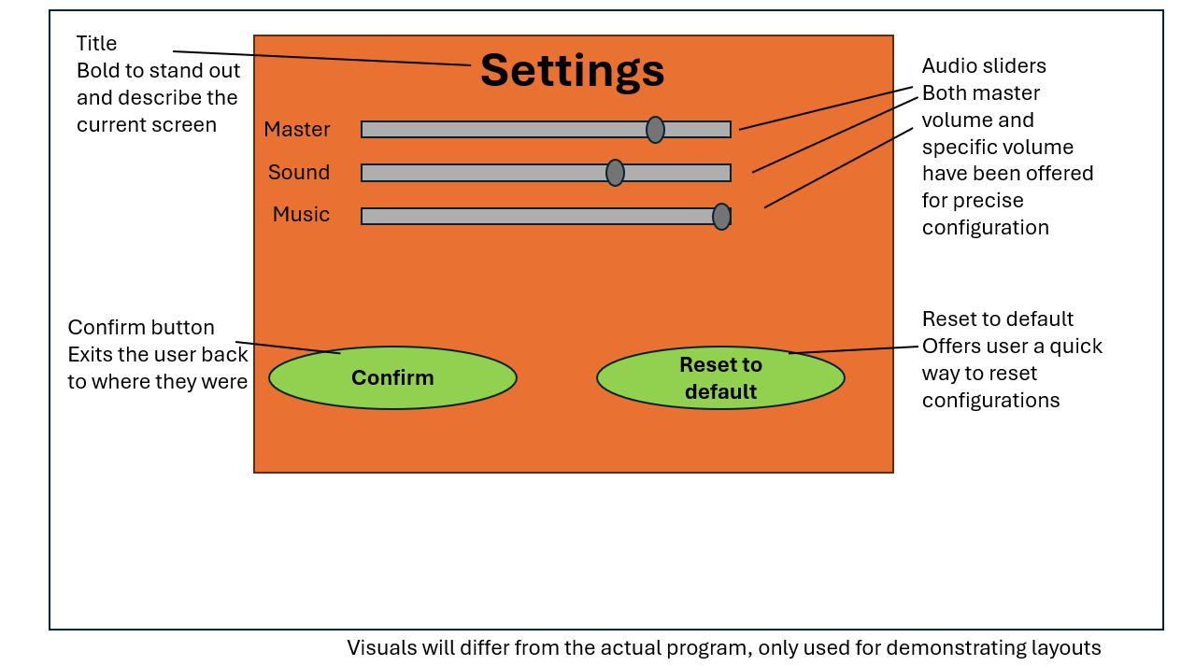

Main level selection screen
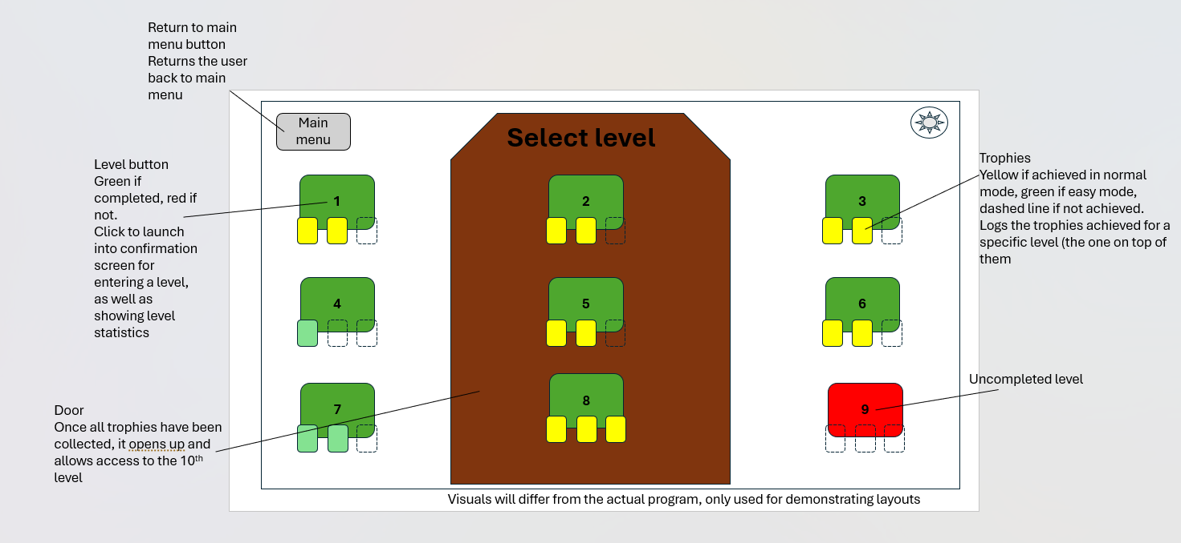
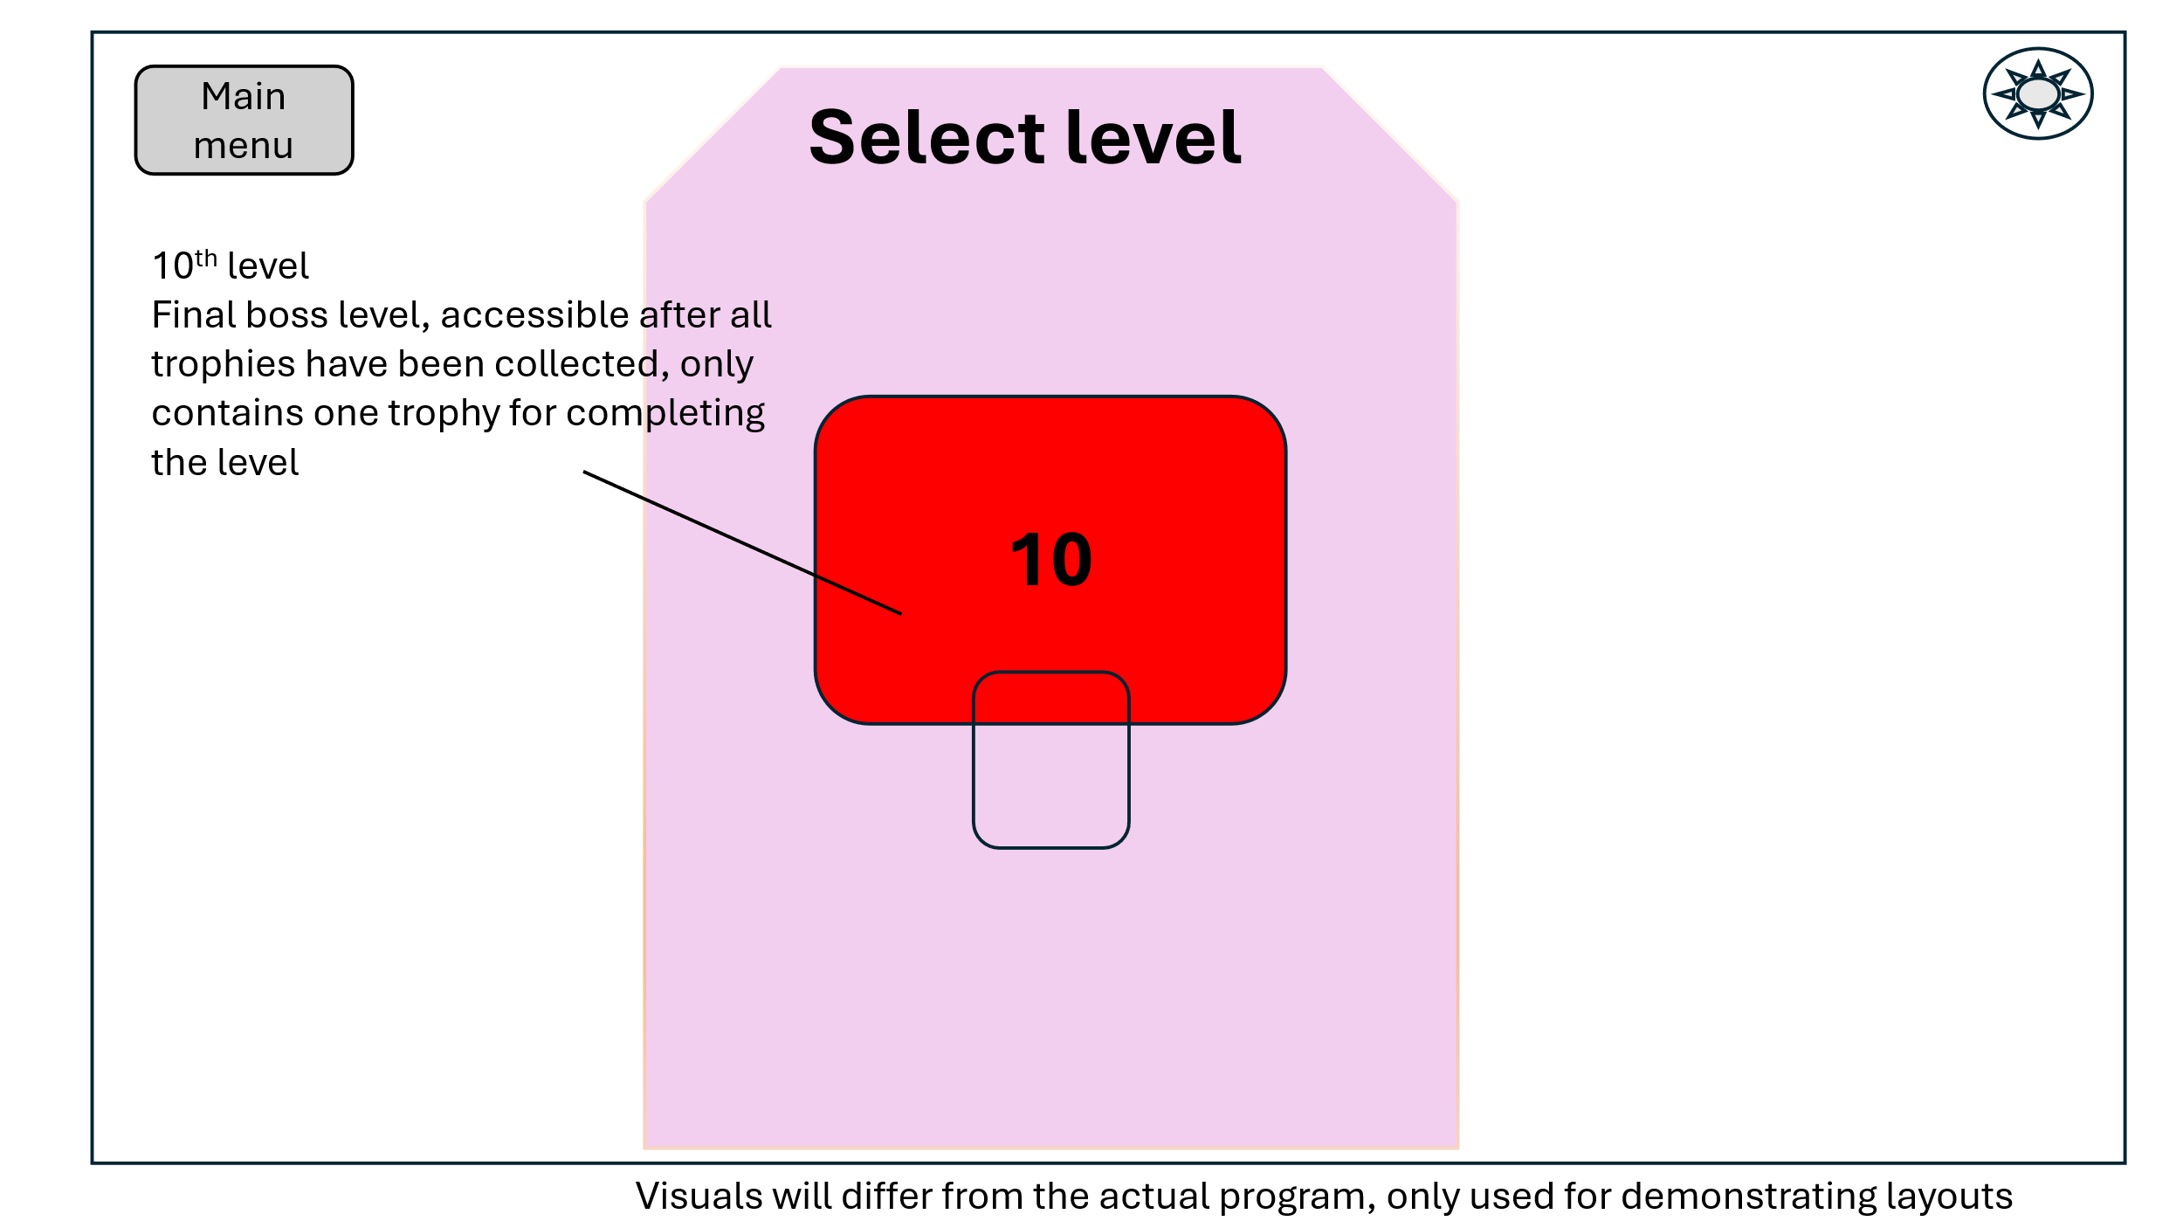

Level select confirmation screen
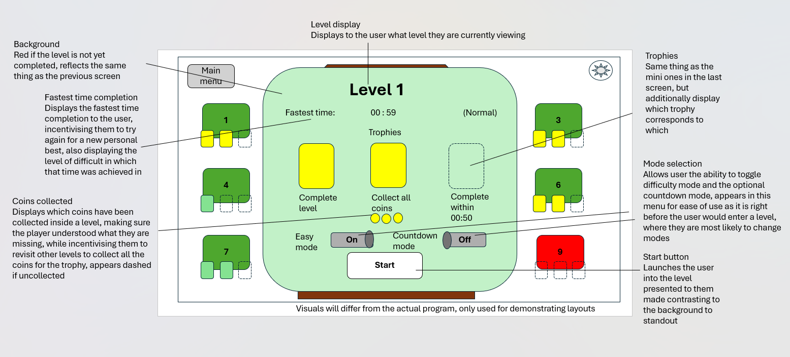
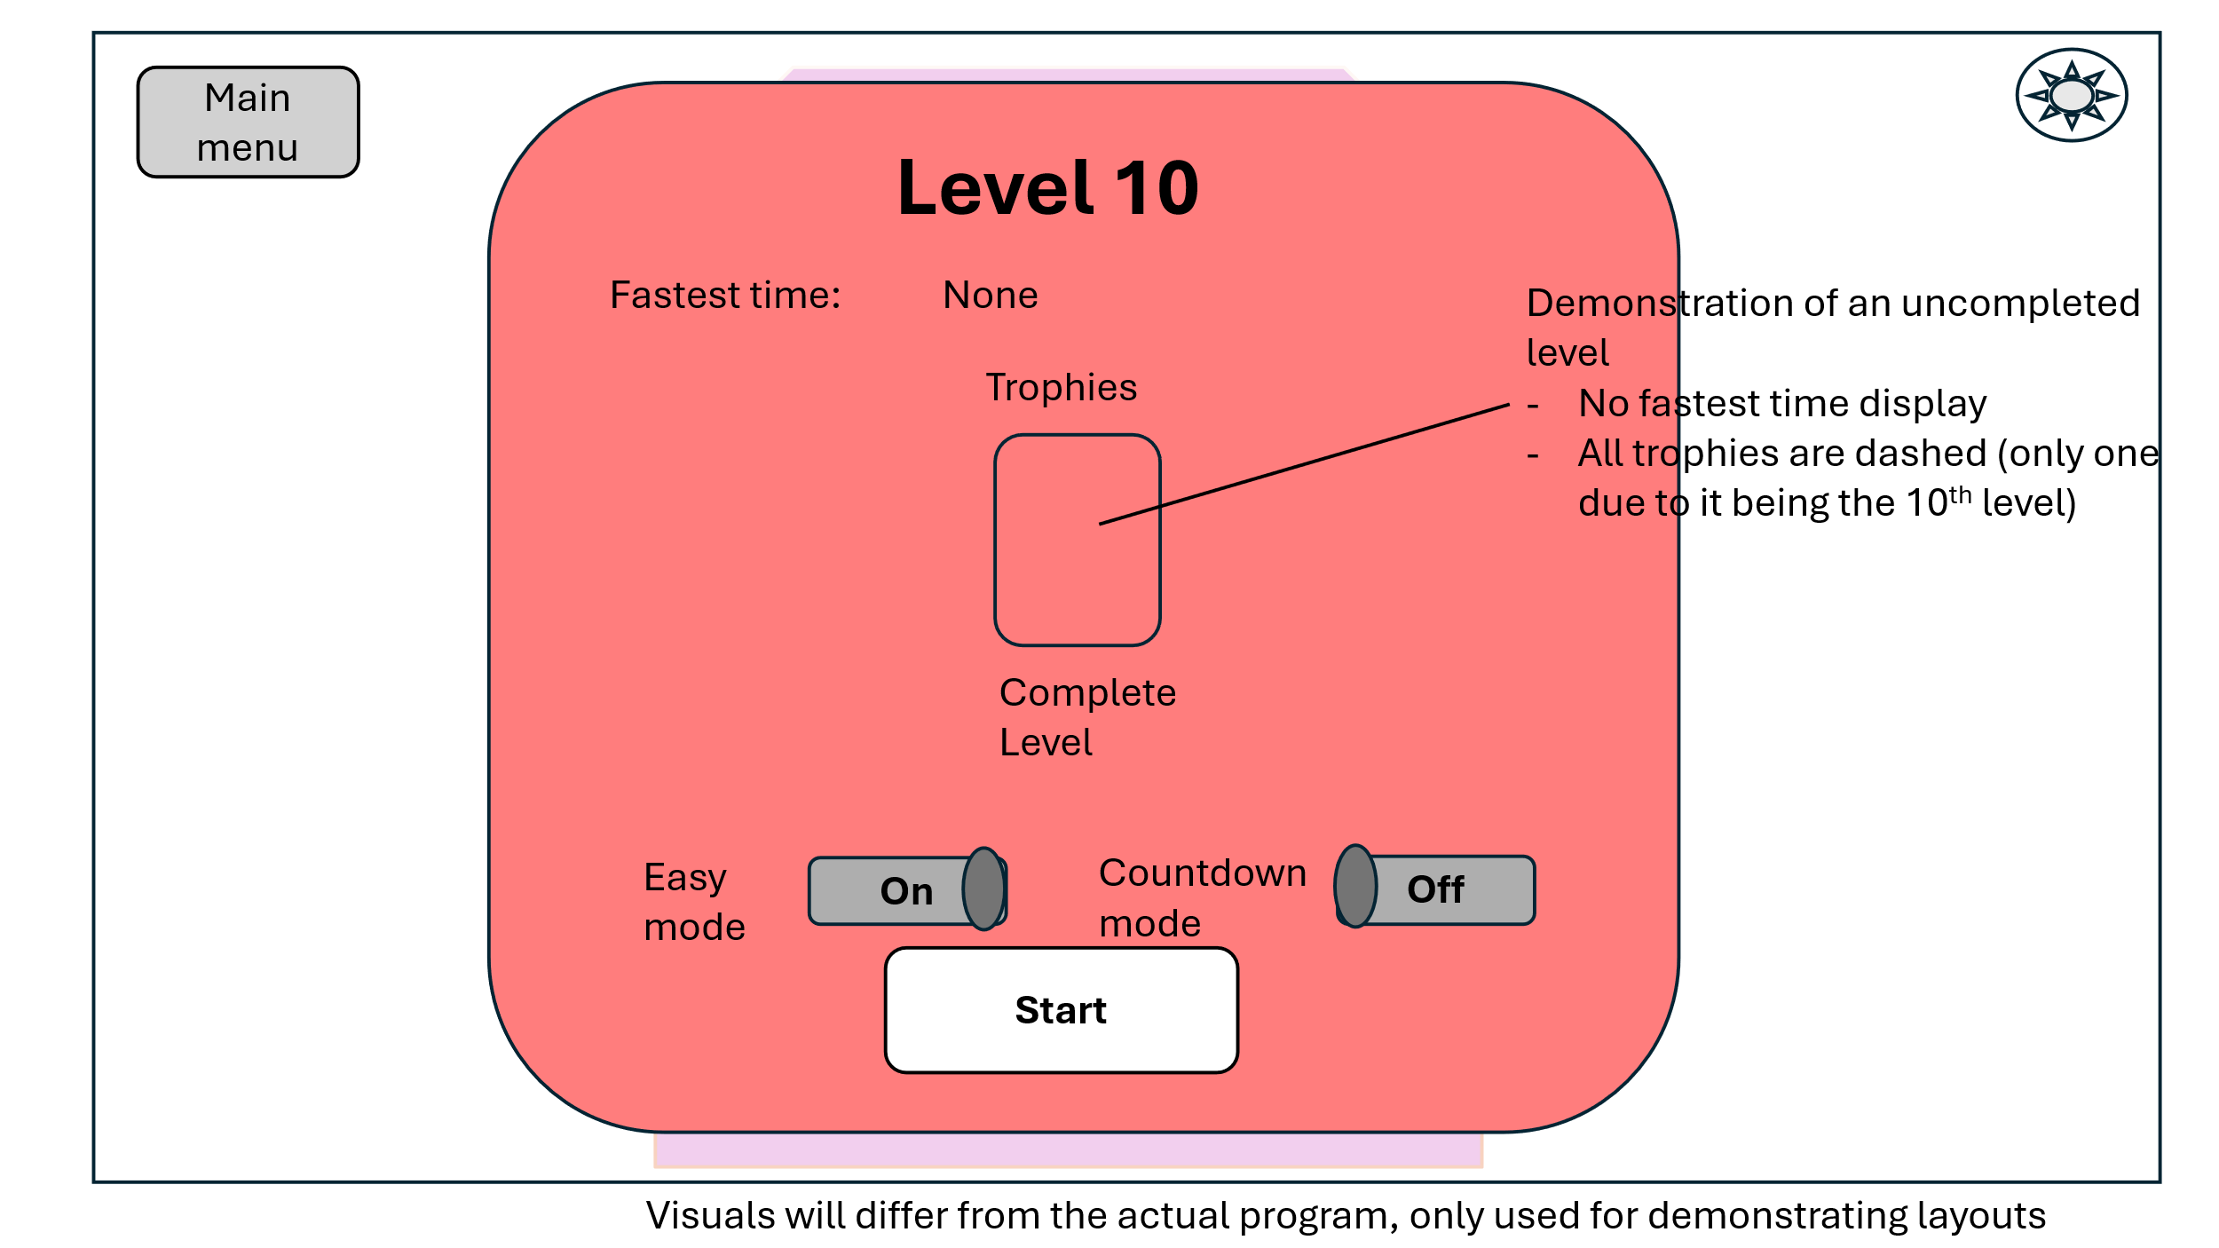

In game HUD layout
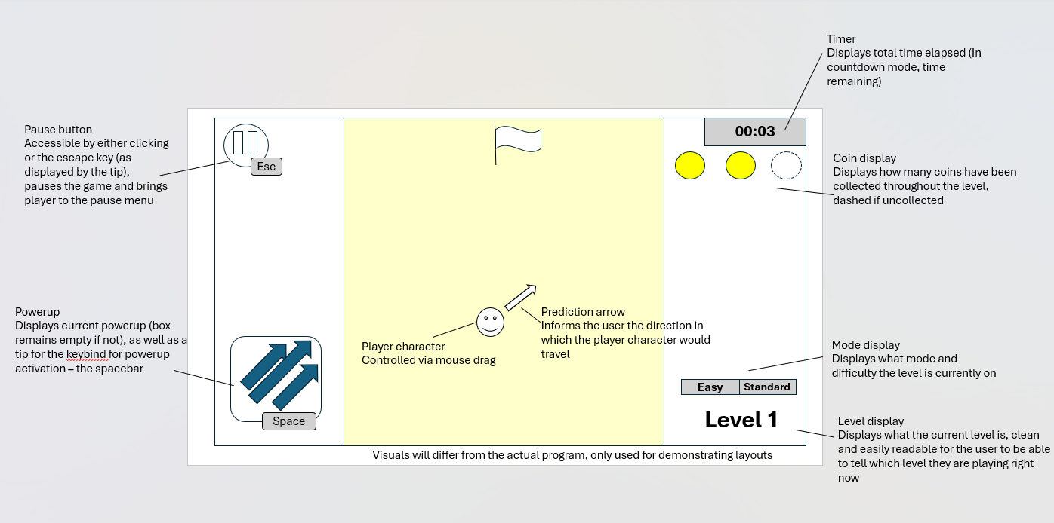

Pause menu
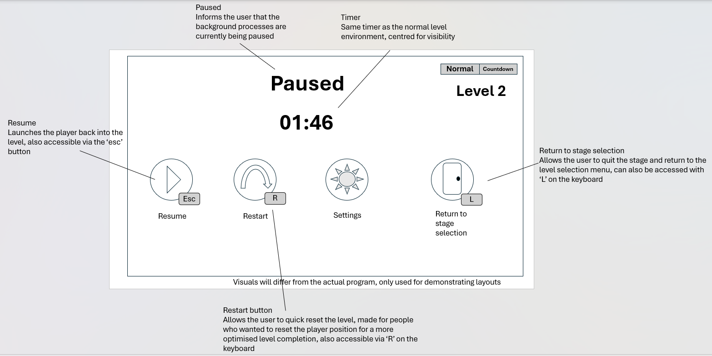

Stage elements
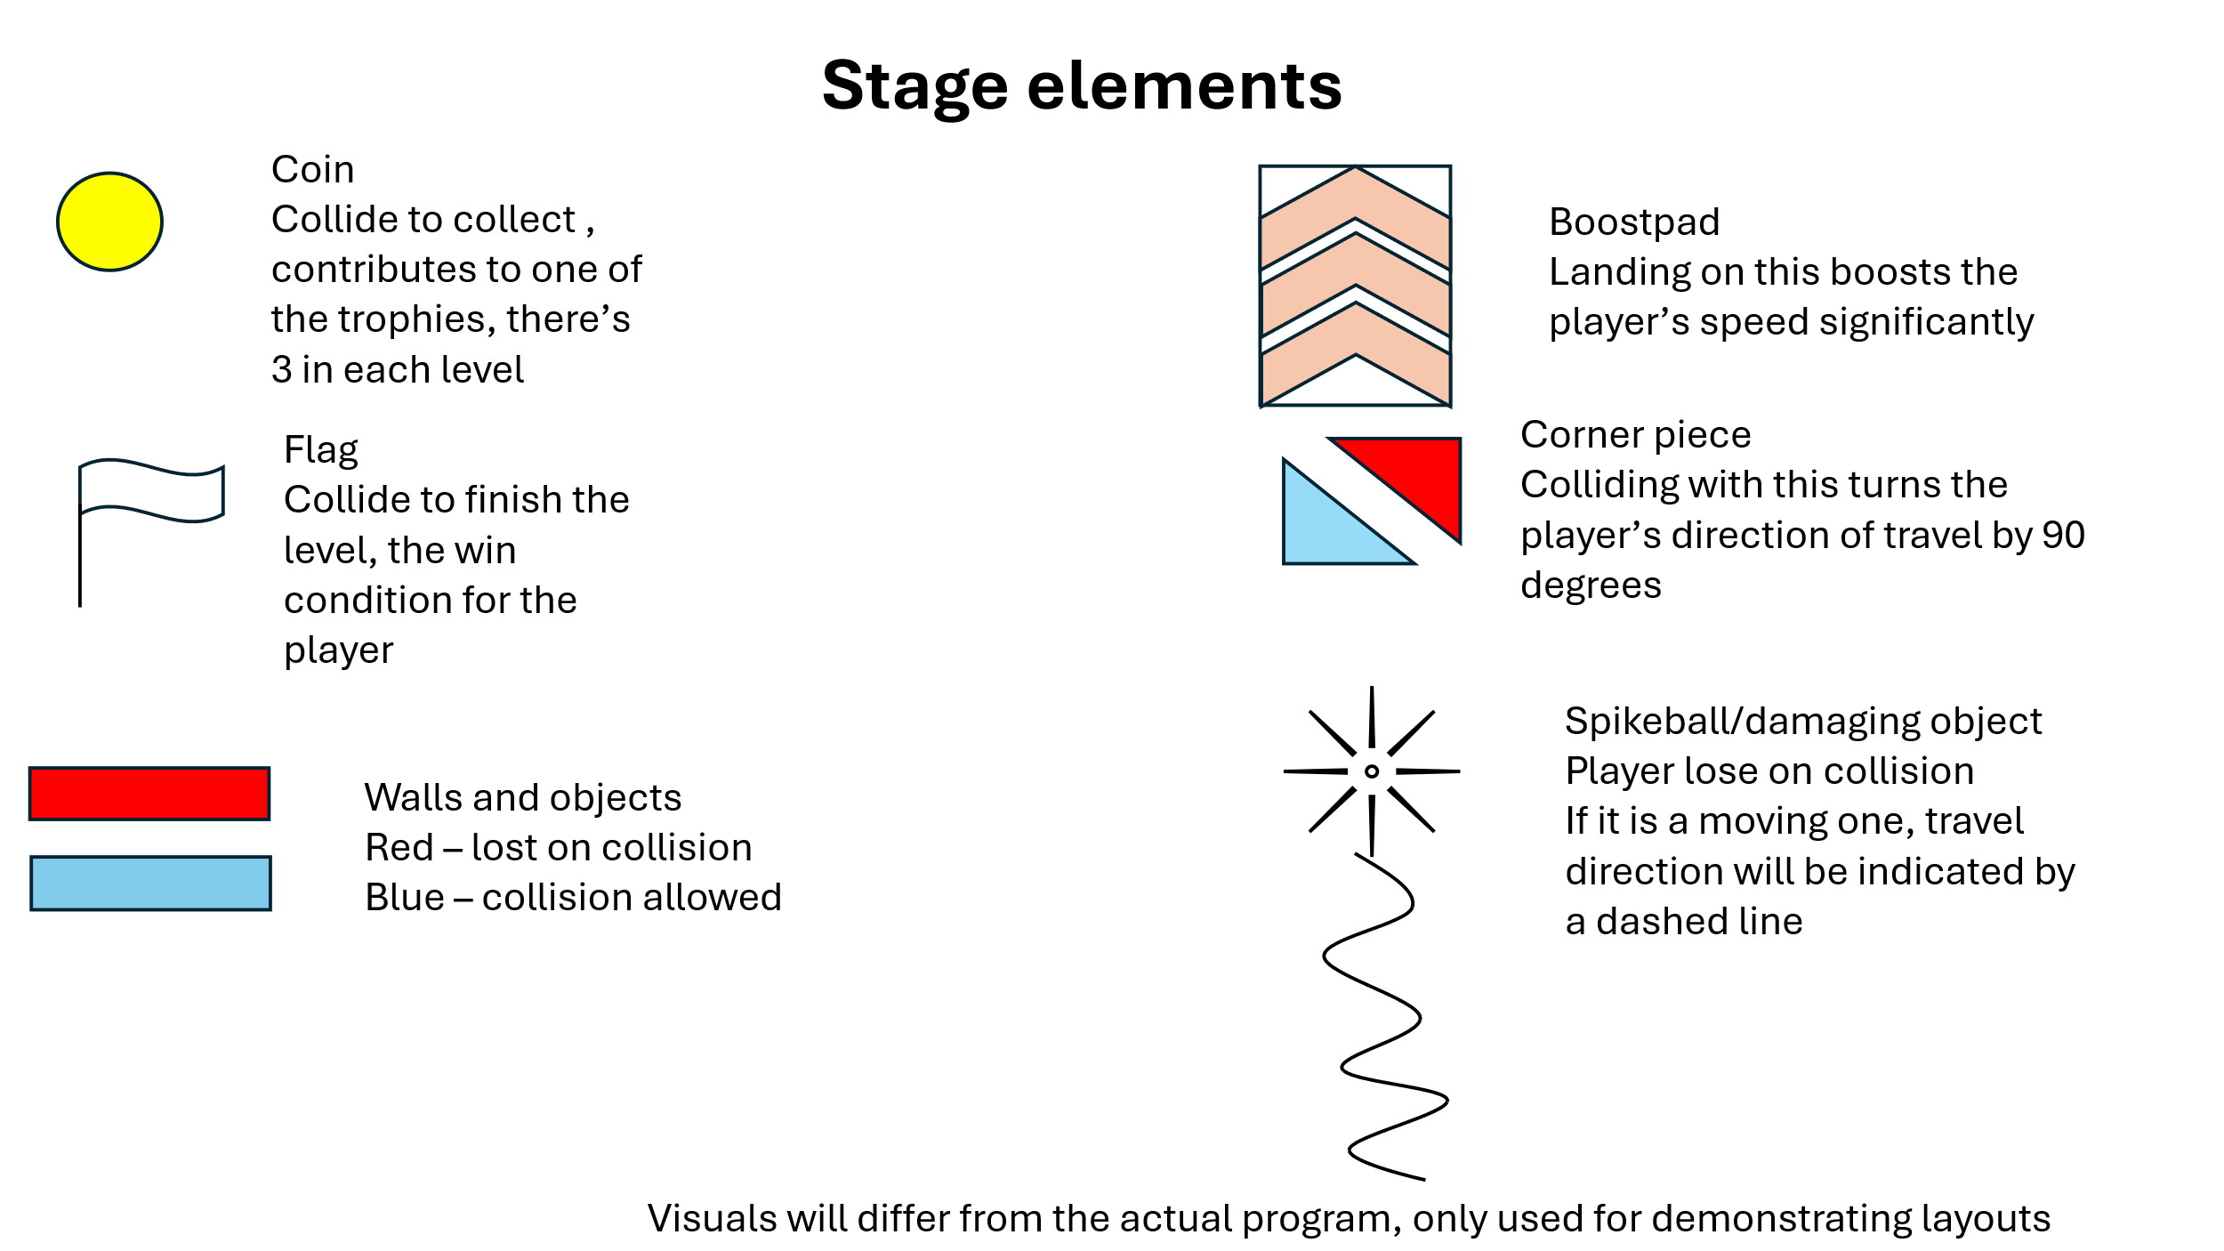
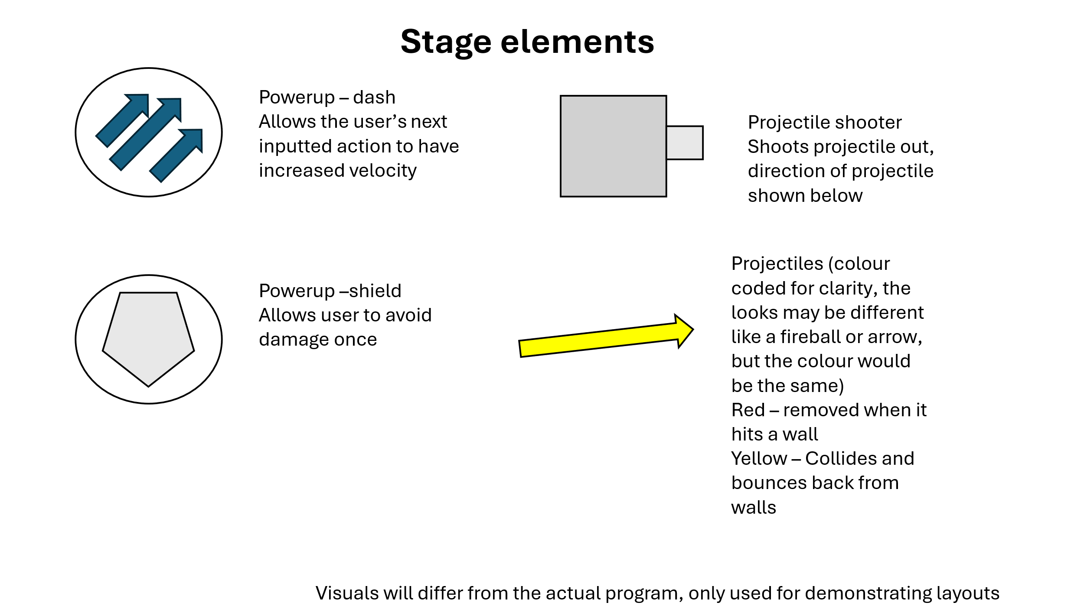
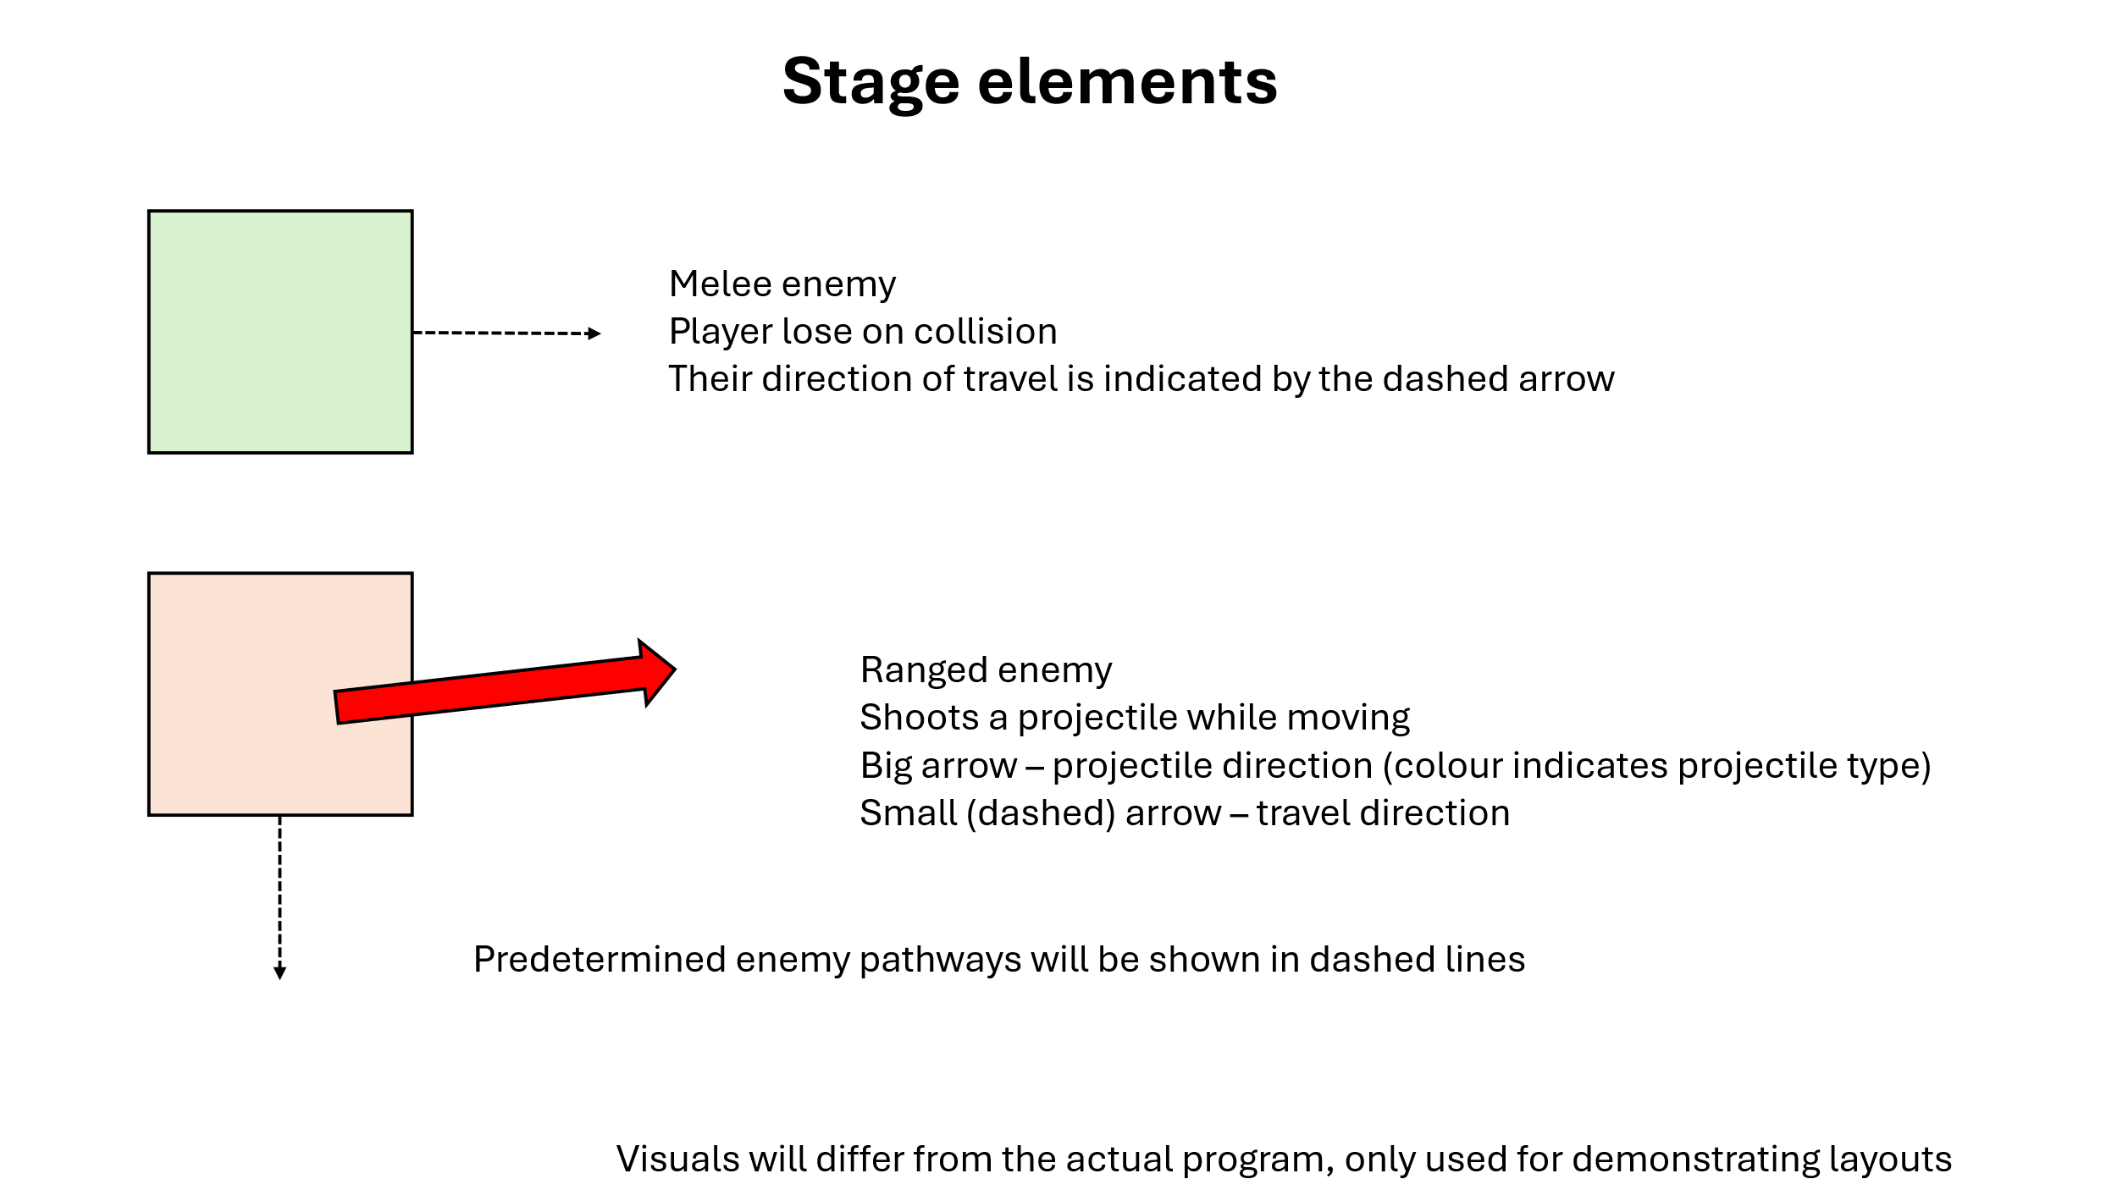

Levels (1-3)
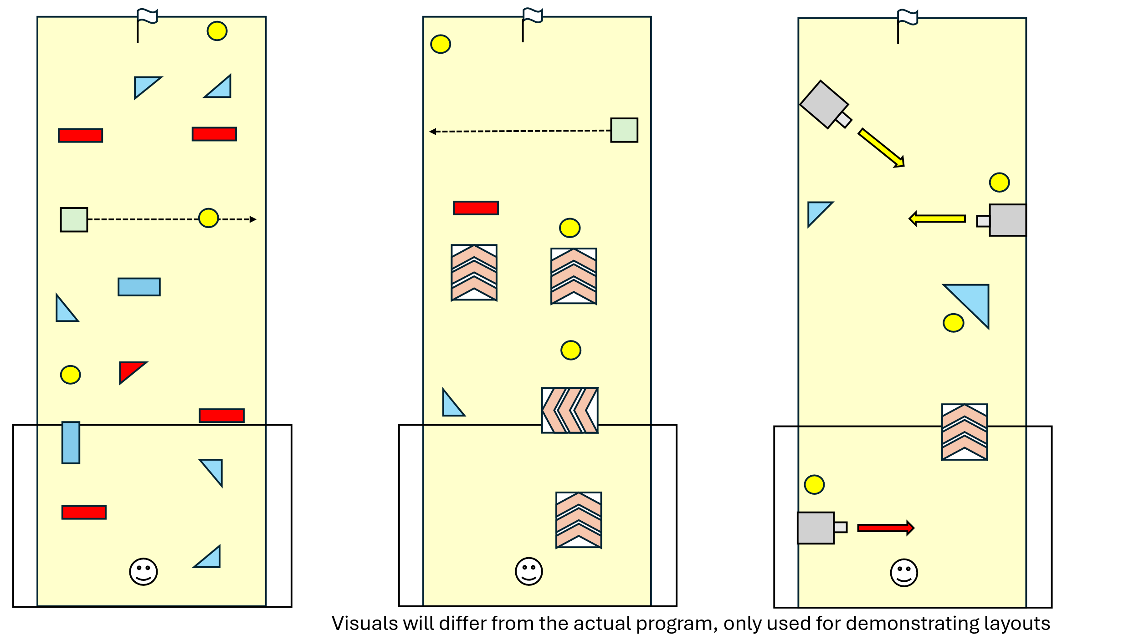
Level 1 is the first level of the game, it introduces the player to a relatively simple layout which they can use to experiment with game mechanics, it also introduces the first enemy in the game, a basic enemy which moves forward and backwards in a straight line. Furthermore, this level should hopefully teach the player that red walls/objects damage the player on collision.
Level 2 introduces players on the boostpad, thus the level is consisted most of boostpads, also introducing them to the idea that it is possible to ride a boostpad onto a wall, which damages the player.
Level 3 introduces projectiles to players, this level showcases ranged attacks from the level from stationary objects, making the player learn about the 2 types of projectiles, ones that bounce (yellow) and ones that don’t (red)

Levels (4-6)
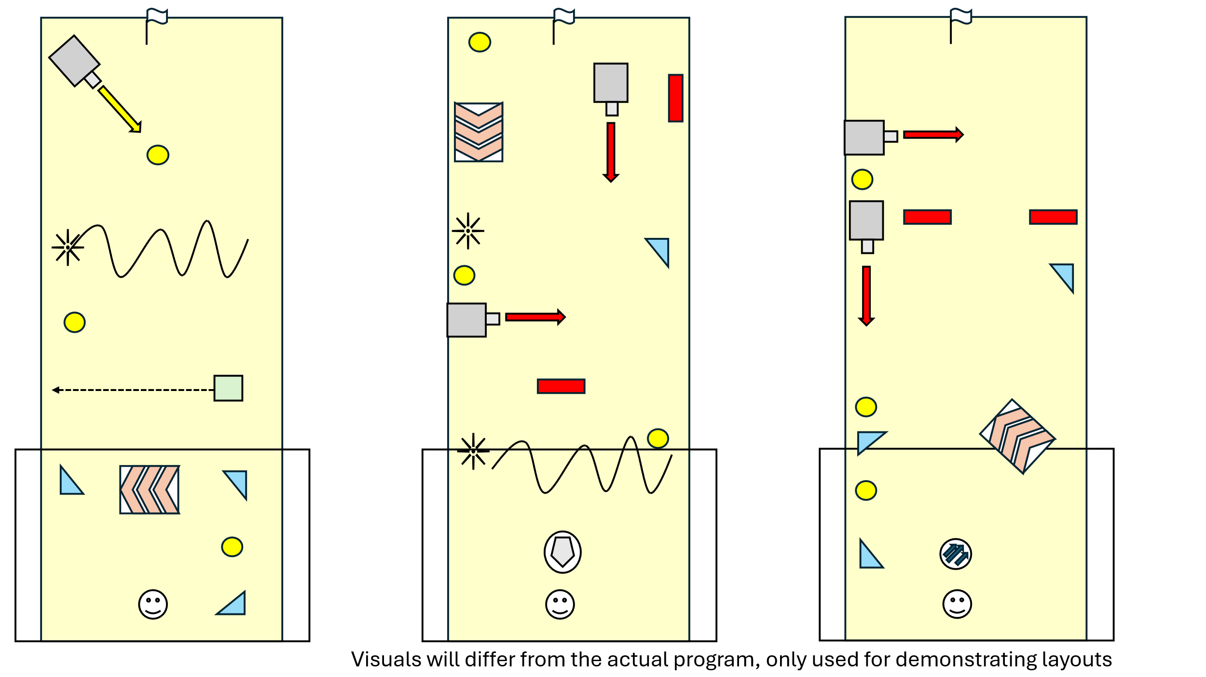
Level 4 introduces spikeballs, the first moving obstacle that actively damages the player, the spikeball move in a wave pattern that the player should be able to tell immediately.
Level 5 introduces our first powerup, the shield, whilst the shield could be completely ignored in this level if the players play perfectly, the idea of a shield being able to block attacks should be common amongst my target audience.
Level 6 introduces the other powerup, the dash, the dash allows the player’s next action to have increased velocity, making it very easy for precise and efficient wins.

Levels (7-9)
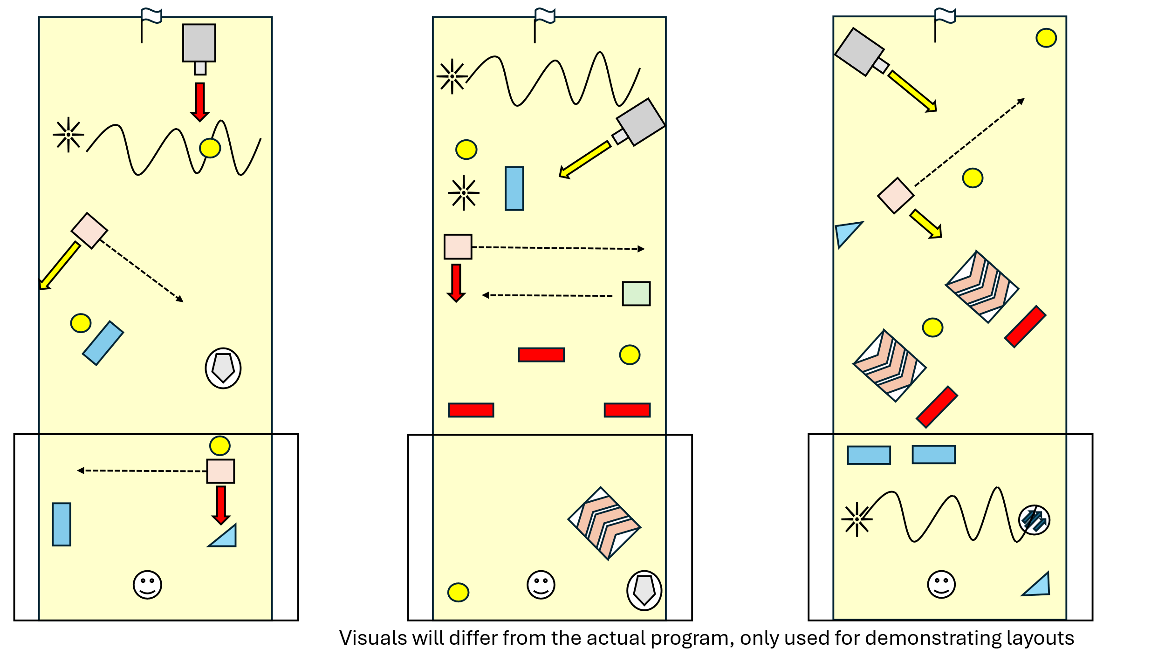
Level 7 introduces the last stage element – ranged enemies, they are able to shoot both red and yellow projectiles (as shown in the level), so the player is able to learn and understand them.
The 8th and 9th to last level of the game are both tests of skill, they make use of most of the mechanics in the game and act as a test for how much the player understands the mechanics and stage elements.

Level 10 (gauntlet)
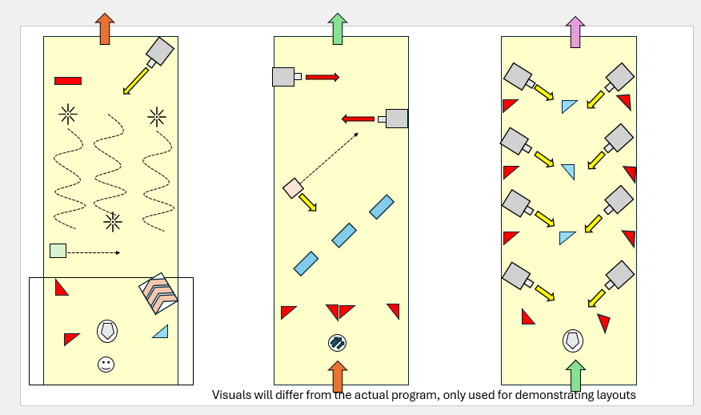
The 10th level acts as a final exam to the player, using a long level equal to 3 normal levels to truly test the players’ skill, before ending in a boss fight.
In the above screenshot, each arrow leads to the arrow of the same colour (i.e. orange arrow at the top of lane 1 leads to the start of lane 2), the level will run from one to the other in the same scrolling screen, once they reach the purple arrow, the boss fight will initiate.

Level 10 (boss fight)
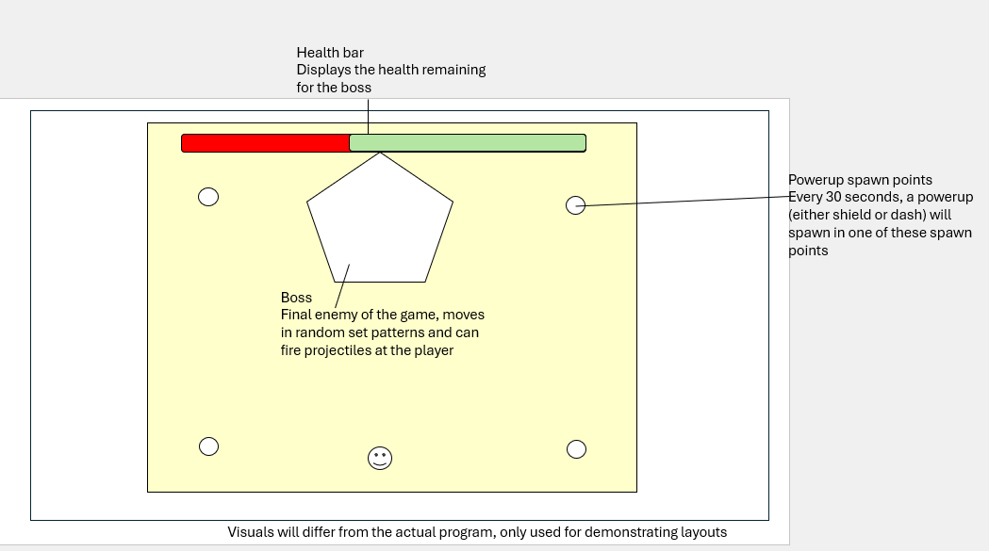
The boss fight in this level will have a health bar, so it can take multiple hits from the player, it is the final challenge for the player.

Structure diagram

Full diagram
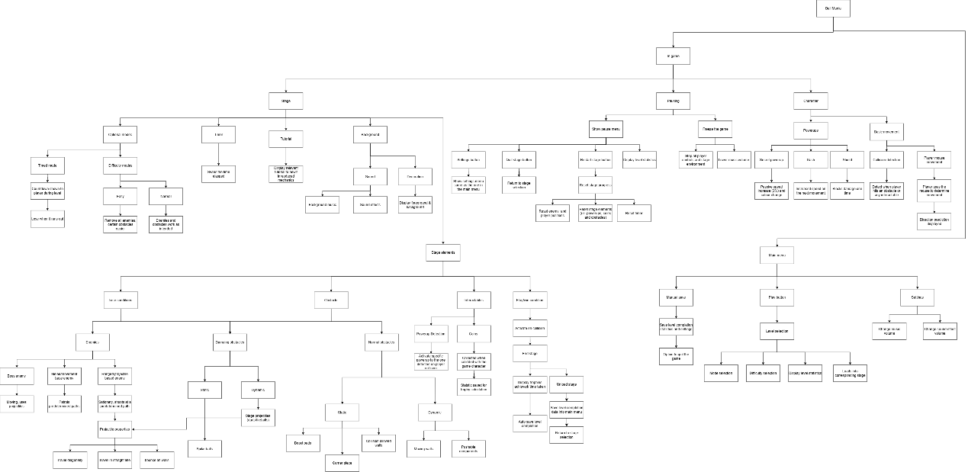

Smaller sections
I have decided to split the structure diagram into 2 main sections – in game and main menu. In game refers to elements of the program that would be involved during a stage, whereas the main menu sections refer to elements that is involved before a level begins such as basic menus.

This section includes the elements outside the main gameplay element, i.e. the main menu, which is split apart to the 3 buttons it contains, and each decomposed to show its features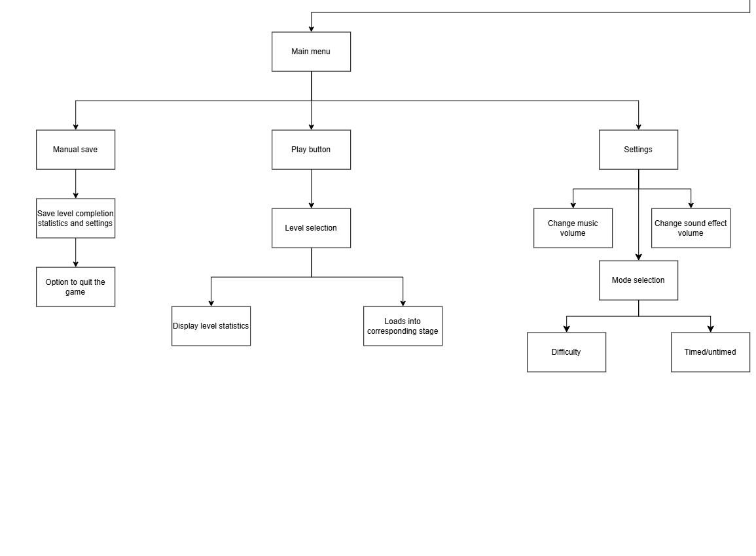.
The next 3 sections are decomposed elements within gameplay, such as all stage elements (such as obstacles), pause feature, the player character and others, each decomposed to show their features and what they do. 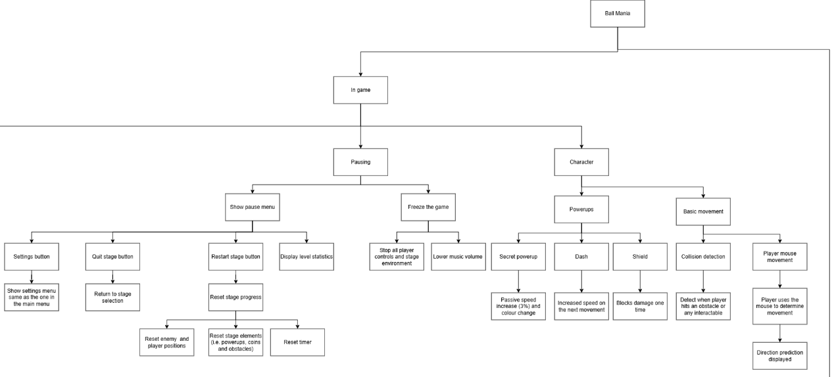
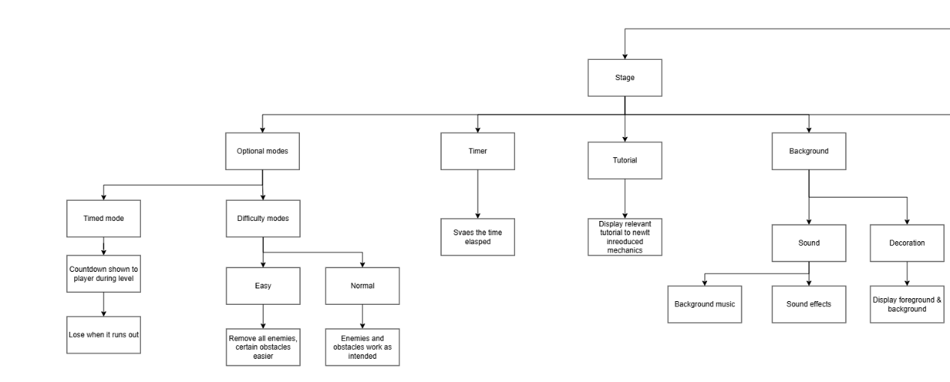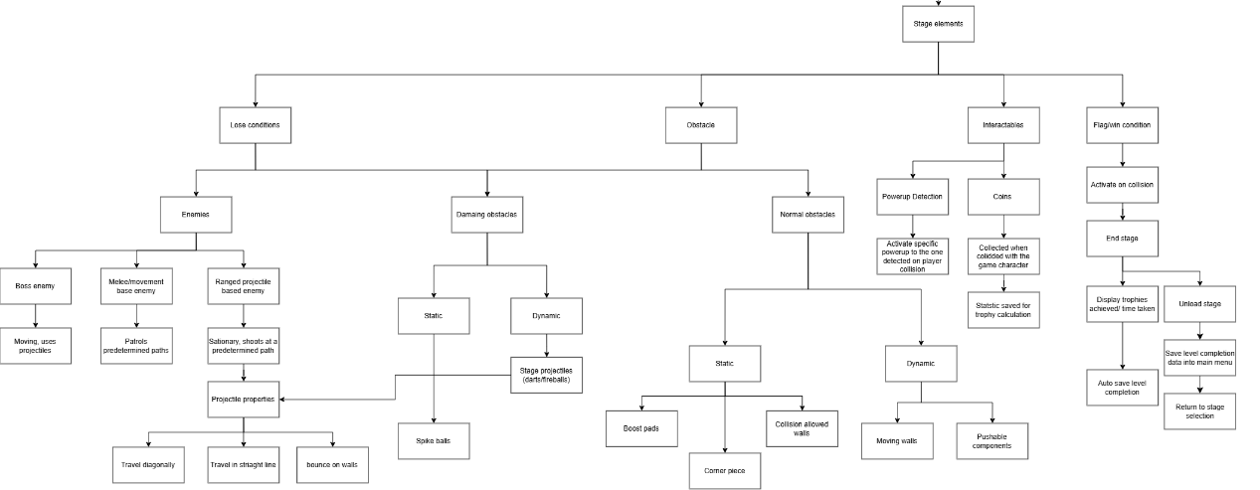

Development plan and test plan

Stage 1 – Basic movement mechanics
Before any other element can be implemented, I must ensure that my stakeholders can control and move the game character. This includes the mouse-controlled movement where the stakeholders would drag the mouse to control the angle and speed that the player character will launch towards, as well as basic collision detection and a prediction on where the player character will move (displayed as an arrow).
Furthermore, variables for the player character will be established here, such as a value for speed, angle.
The collision detection is made in a form where the program will return the object that the player character has collided with, since we have not made anything other elements for the player character to collide with yet, only the function will be made.

Features to implement
- Mouse controlled movement
- A prediction arrow for movement
- Collision detection (properly detects an object in contact)
- Set up variables and values for the player character

Test No. | Description | Test type | Test data | Expected outcome | Actual outcome
1 | Does the ball move according to the cursor? | Valid | Run program | The ball would move when the mouse is released and launches in the correct speed and direction in relation to the cursor
2 | Does the prediction arrow accurately represent the direction the ball would move? | Valid | Run program | The arrow should be in the same direction the ball would move, acting as a reliable prediction
3 | Does the function properly return an object that the player character collided with? | Valid | Run program | The function would return the object in which collided with the player character
4 | Is there a getter and setter for all relevant variable inside the player character? | Valid | Passing arguments into relevant functions | The program should be able to reliably update the data within the player character

Stage 2 – Initial stage elements

Now we will add elements in which the player character can interact with, building upon the collision detection system, we will now implement what happens after the player character collides with a specific stage element (such as winning when it collides with the finish flag, or get a speed boost on collision with the boost pad)
This will include making most of the building blocks that we would need in order to create a level in the game, including static elements that the player character can interact with.
Powerups cannot be stacked on each other, the dash power up can be cancelled on its activation (with the space bar) and saved for later use. When a new power up is collected, the new one should replace the old one.

Features to implement
- Static obstacles that the player character can interact with
  - Spike balls
  - Boost pad
  - Corner piece
  - Collision-allowed walls
  - Normal walls
- Power-ups
  - Dash – Press space bar to have the next movement to have a boosted speed (visual cues will be present), press space again to cancel
  - Shield – avoid damage once
- Collectibles
  - Coins to collect
  - Coins collected are properly tallied
- Win condition (flag)
Test No. | Description | Test type | Test data | Expected outcome | Actual outcome
1a | Does colliding with the spike ball cause the player to lose the game? | Valid | Run program | The program should display a lose message (place holder)
1b | Does colliding with the boost pad boost the player character forward? | Valid | Run program | The player character should be launched at a suitable speed and distance according to the direction the boost pad is facing
1c | Does hitting a corner piece turn the direction travelled by the player character 90 degrees? | Valid | Run program | The player character should have their direction of travel turned 90 degrees, while feeling smooth and accurate
1d | Does hitting a collision allowed wall causes the player to lose the game? | Invalid | Run program | The program should proceed as normal and the player character would bounce on the wall with relatively accurate physics
1e | Does hitting a wall causes the player to lose the game? | Valid | Run program | The program should display a lose message (place holder)
2a | Does collision with a powerup cause it to be removed from the level? | Valid | Run program | The powerup in question should be removed on collision
2b | Does the powerup collected give the correct powerup? | Valid | Run program | The program should allocate the corresponding powerup to the player character
2c | Does pressing space bar when in possession of the dash powerup apply the correct effects? | Valid | Run program | The player character should have a noticeable increase in the velocity of their next move
2d | Does pressing space bar again after activating the powerup disable the powerup | Valid | Run program | The player character should no longer have the effects of the powerup and the dash powerup can be activated again later
2e | Does collecting the shield cause the player to avoid damage once? | Valid | Run program | The player character should not lose when in possession of a shield upon taking damage, the shield is removed instead
2f | Does the powerup get properly removed after they’ve been used? | Valid | Run program | The program should remove the powerup state from the player after its use
2g | Does getting a new powerup whilst in possession of one overwrite the old one? | Valid | Run program | The new powerup should replace the old one
3a | Does colliding with the coin remove it from the level? | Valid | Run program | The program should remove the coin from the environment
3b | Is there a tally inside the environment that keeps count of the coins collected (no display made yet) | Valid | Run program & check variables stored | The program should have a variable made that accurately tracks the number of coins collected
4 | Does hitting the flag complete the level? | Valid | Run program | The level should be completed (display isn’t done yet so a place holder is shown)

Stage 3 – Advance stage elements

At this stage, I will work to include more dynamic stage elements within the game that increases the complexity of the gameplay, leading to an overall improved experience playing the game.
This would include enemy mechanics, which would have enemies move in set pathways or shoot projectiles at a set direction. Furthermore, projectiles will also have different properties such as speed, size, or the ability to bounce on walls. I will also give the player an option to combat the enemy via running into them (on contact during a move, the enemy is eliminated), then the player character would bounce off the eliminated enemy.
This would also include moving elements in a stage, such as moving obstacles that would move the player character.

Features to implement
- Melee enemies (moves in a set pattern)
- Ranged enemies (shoots projectiles)
- Projectile properties
  - Set up parameters and values for these properties
- Moving stage elements
  - Stage projectiles (cannot be disabled by combat) such as darts or fireballs

Test No. | Description | Test type | Test data | Expected outcome | Actual outcome
1a | Does collision with a melee enemy damage the player? | Valid | Run program | On collision with the player character, the player character should take damage
1b | Does the melee enemy travel in the predetermined pathway? | Valid | Run program | The melee enemy should function as described
2 | Does ranged enemies shot projectiles? | Valid | Run program | The ranged enemies should be able to shoot projectiles
3a | Does projectiles (from enemies and obstacles) damage the player? | Valid | Run program | The projectiles should damage the player on collision
3b | Does the projectiles possess the correct properties (travel direction, bounce on walls?) | Valid | Run program | Projectiles should work as intended and each projectile should function properly according to its described property
4 | Does intended stage elements shoot projectiles? | Valid | Run program | The stage elements that can shoot projectiles should work as intended

Stage 4 – Level creation

Now that our building blocks are done, we can make the levels, there will be a total of 9 levels created in this level, each level being different in some way. Obstacles will be slowly introduced throughout each level.
Navigation between levels will be created in stage 4, so for now level completion will lead to a place holder environment. Tutorials and timer display will be included in stage 4 as well treated as a Heads-Up Display (HUD).
Structure that levels will use will also be created here, such as parameters on optional modes will be prepared for the future

Features to implement
- All 9 levels planned for this stage
- Level completion link to a placeholder main menu
- Structural elements required for each level (i.e. parameters)
- Levels can track completion status such as timer and coins collected
  - A method to calculate the number of trophies achieved

Test No. | Description | Test type | Test data | Expected outcome | Actual outcome
1a | Can all the levels be completed? | Valid | Run program | The levels should be completed on collision with the flag
2 | Does the level completion message display for each level? | Valid | Run program | Each level should lead to the place holder display
3 | Are the parameters properly saved somewhere into the level on creation? | Valid | Pass arguments into relevant functions | Parameters such as difficulty and mode should be properly saved (even if not yet implemented)
4a | Does the game accurately track the time elapsed inside a level? | Valid | Run program & check variables | The program should accurately track the number of minutes & seconds passed since the level started
4b | Is the trophy calculation accurate to what’s achieved in the level? | Valid | Run program & check variables | The program should accurately calculate the number of trophies achieved

Stage 5 – Visual menus and displays

This stage includes implementing most of the visual displays for the game, as well as the menu navigation required to connect between levels.
This includes a display for tutorials within certain levels whenever a new mechanic is introduced, it will be implemented as a static image that displays information required for the new mechanic; The pause menu and all of the functionalities that comes with it; The main menu, as well as the level selection menu.

The pause menu should pause all elements of the game and is accessed by the escape key.

Features to implement
- Main menu
  - Quit button (only exits game for now)
  - Play button, directs towards the level navigation menu
  - Settings button, directs towards a placeholder
- HUDs
  - Time elapsed
  - Pause button, lead to the pause menu
  - Coins collected
- Pause menu
  - Pauses the game
  - Return to level navigation
  - Settings button
  - Restart button
- Level navigation menu
- Display level completion statistics such as trophies and time elapsed on level completion
- Level loss displays
- Tutorial displays

Test No. | Description | Test type | Test data | Expected outcome | Actual outcome
1 | Are the buttons in the main menu functional? | Valid | Run program | The program should lead the user to the respective page
2a | Is the time elapsed properly displayed to the player? | Valid | Run program | The display should show an accurate timer to how long the level has been running for
2b | Is the number of coins collected in a level displayed to the player? | Valid | Run program | The display should accurately show the number of coins collected in the current level
3a | Does pressing escape (or using the button built in the environment) inside a level bring up the pause menu? | Valid | Run  program | The game should freeze and display the pause menu
3b | Is the game environment paused when the pause menu is brought up? | Valid | Run program | The game environment should be completely frozen (i.e. any processes such as movement and timer)
3c | Does the restart button prompt the level to be reinstated from the beginning? | Valid | Run program | When the restart button is pressed, the level should be reset to the beginning
3d | Does the return to level navigation button return the user to the level navigation menu? | Valid | Run program | The program should direct the user back to the level navigation menu
3e | Does the settings button correctly function? | Valid | Run program | The settings menu should be brought up
4 | Can we navigate into a level using the level navigation menu | Valid | Run program | The game should allow the user to enter into the correct level using this menu
5 | Are level completion statistics displayed within the level navigation menu | Valid | Run program | The game should display the correct statistics such as completion time to the user.
6 | Is there a proper display that allows the user to return to level selection or restart on level loss? | Valid | Run program | Feature should work as described.
7 | Are tutorials present on specific stages where relevant? | Valid | Run program | The program should display a small tutorial in image form that explains a new mechanic introduced in this level

Stage 6 – Visual and audio improvements & configurable settings

In this stage, we will be implementing the background elements in the game that is not gameplay oriented but aims to improve overall gameplay experience instead.
This includes sound effects, background music, background and foreground in levels and visual effects.
The pause menu would grey out the background and make the music quieter.
We would also implement the settings feature in this stage as it links directly to what we just added, we will provide a configurable setting that the stakeholders can use to accurately edit separate audio volumes separately or as a whole (master volume)

Features to implement
- Sound and visual effects on certain conditions
  - Winning a stage
  - Getting hit/losing
  - Activating a powerup
  - Interacting with obstacles
- Background music that plays in each level and menu
- Configurable settings
  - Audio effects can be configured

Test No. | Description | Test type | Test data | Expected outcome | Actual outcome
1 | Does sound effects and/or visual effects occur when conditions meet (conditions above) | Valid | Run program | A sound or visual cue should be heard/seen each time an interaction occurs
2 | Does background music play when a new menu/level is presented. | Valid | Run program | A background music track should be played whenever there is a new environment presented
3a | Can audio settings be configured? | Valid | Run program | There should be options to tweak sound effect, music and overall volume
3b | Can the program catch attempts to increase/decrease audio beyond 100%/0%? | Extreme | Pass arguments to relevant functions | The program should only allow audio values going from 0% to 100%

Stage 7 – Save and load

By stage 5, the game should be minimally functional, we can play the game from start to finish and we can see our level completion. Now we will work on saving the progress and loading it back in when we reboot the game.
We will need to create controllers that can read and write the level completion data into the local storage of our stakeholder, I will be using an XML file for this, and store data such as level completion, fastest time, and trophy collection into the file, and upon booting up the game again, the program should read into this XML file and restore the state of the game as we left it off.
Furthermore, this includes both a manual save (the quit button) and an auto save feature (upon level completion) that would use the system to save the game to avoid progression loss.

Features to implement
- A base .xml file that we start the game with (a template)
- A system that would read the .xml file and be able to replicate what it read into the main game
- A system that would be able to write or edit the .xml file according to what the game environment right now.
- Manual save attached to the quit button found in the main menu
- Auto save that occurs at the end of each stage.
Test No. | Description | Test type | Test data | Expected outcome | Actual outcome
1 | Is the .xml file descriptive and capable of storing all the data needed for the functionality of the game? | Valid | Run program & check .xml file | The program should product a .xml file that contains all the data for each level such as completion status
2 | Is the program capable of reading from an .xml file and applying the data that it read from it into the game? | Valid | Run program | The program should accurately take data from the .xml file and be able to display it
3 | Can the program save progress made and configurations on the game onto a .xml file without any loss in progress? | Valid | Run program | The program should be able to reliably save all progress into an .xml file.
4 | Does quitting the game manually save progress? | Valid | Run program | The program should save progress when the ‘quit’ button in the main menu is pressed
5 | Does completing a level cause a progress save automatically? | Valid | Run program | Progress should be auto saved upon completion of the level

Stage 8 – Optional modes

Here, I will be implementing optional modes that the stakeholders can choose to enable or disable inside the level selection menu.
Outline of each optional mode
- Timed mode: A set timer would be shown that ticks down instead of counting up, the level is lost when the timer hits 0
- Difficulty modes (Easy): All enemies are disabled, and all stage projectiles will travel at half the usual speed. Normal mode is the intended experience

Features to implement
- A way inside the level selection menu to enable optional modes
- Trophy achieved in easy mode would be different in display compared to normal mode
- Timed mode can be selected and implemented
- Easy difficulty modifications made to each stage

Test No. | Description | Test type | Test data | Expected outcome | Actual outcome
1 | Is there toggles present in the settings menu to toggle the extra modes? | Valid | Run program | There should be toggle switches that enables or disables the timed mode and easy mode.
2 | Is there a distinctive difference in the display for achievements in easy and normal mode? | Valid | Run program | The time achieved and trophies acquired should be shown in a different, contrasting colour in easy mode (compared to normal mode)
3a | Is there a timer counting down instead of up in timed mode? | Valid | Run program | The timer should be counting down from a set number
3b | Does the timer hitting 0 in timed mode cause a level loss in timed mode? | Valid | Run program | Level loss display should be shown when the timer hits 0 on timed mode
4a | On easy mode, is there enemies present in levels? | Invalid | Run program | There should be no enemies present in levels on easy mode
4b | On easy mode, is the projectiles produced from all sources 50% slower? | Valid | Run program | Projectiles should be slower in easy mode

Stage 9 – Boss fight

Finally, this will act as a final stage 10 of the game, I left it in the end as I view this as a desired but not essential part of the game, as the game is largely completed without this stage.
The special level will be unlocked when all trophies have been collected in the game (either trophies from easy or normal mode can unlock the boss fight).
The boss fight will contain a vastly different stage compared to the usual stages, the boss would have a health component (halved on easy difficulty) that is displayed to the players, and they can do damage to the boss via colliding with it.

The boss will attack back via projectiles and can evade attacks in by attempting to move in a set environment. The boss will take multiple hits to defeat and a health bar will be used to display its health, taking damage from collisions by player movement according to player velocity.
Every 30 seconds of gameplay, a random powerup is dropped into the arena, giving the player a boost.
This stage will only have 1 trophy for completing it, and upon collecting all trophies will unlock a secret powerup that can be toggled for the stakeholders as a reward for making it this far.
The secret powerup will change the visual design of the player character and grant a cool down dash (has different visual effects to the dash powerup).

Features to implement
- Stage design and background for the 10th stage
- Boss movement mechanics
- Boss projectile mechanics
- Boss health mechanics & display
- 100% Completion message & reward
  - Toggle for secret powerup
  - Secret powerup features

Test No. | Description | Test type | Test data | Expected outcome | Actual outcome
1 | Can the 10th stage be only accessed when all trophies are collected? | Valid | Run the program | The stage should only unlock when all trophies are collected
2 | Does the boss move and attack as intended? | Valid | Run the program | The boss should move and attack occasionally according to a random value in set directions and attack patterns
3 | Is the boss’ health tracked and displayed properly? | Valid | Run the program | The boss should have a health bar display that show how much health it has left
4 | Does damaging the boss (same way as enemy combat) accurately decrease health? | Valid | Run the program | Damage on the boss should be accurately calculated and displayed
5a | Does completing the boss stage properly reward the players? | Valid | Run the program | The program should reward the players by a thank you display and unlocking a togglable powerup
5b | Does the secret powerup functions as expected? | Valid | Run the program | The secret powerup should grant the player a dash (controlled by a cool down) that can stack with other abilities

